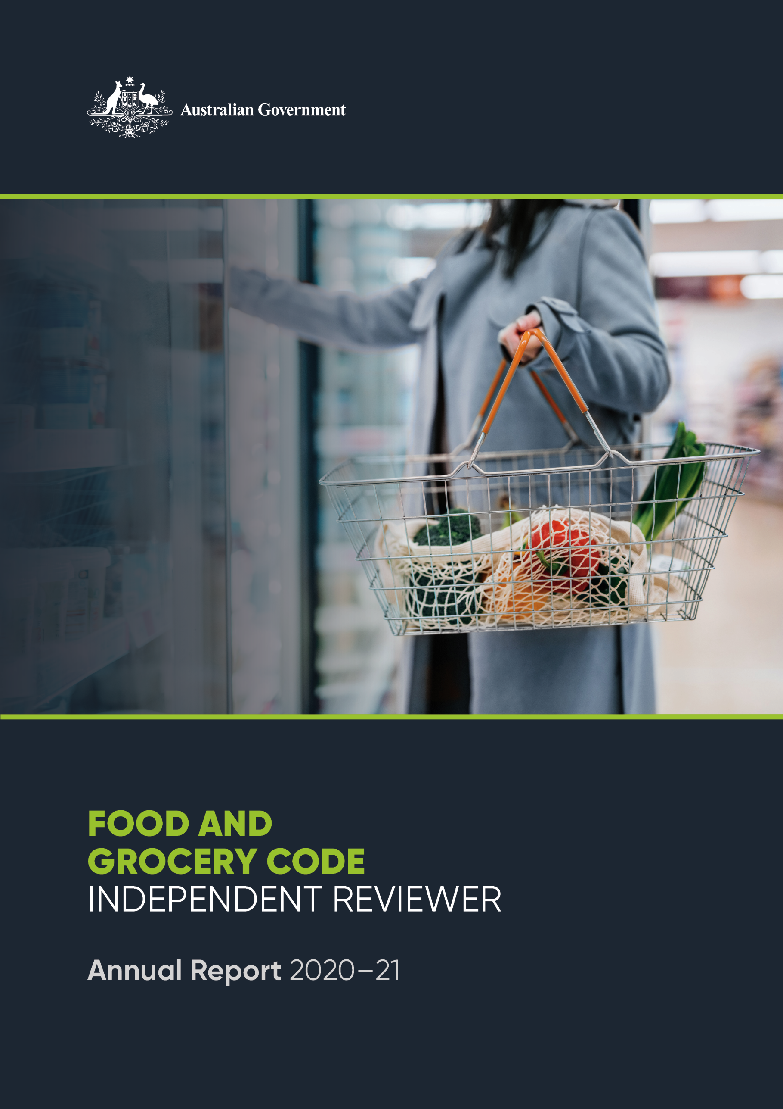

© Commonwealth of Australia 2021

This publication is available for your use under a [Creative Commons Attribution 3.0 Australia](http://creativecommons.org/licenses/by/3.0/au/deed.en) licence, with the exception of the Commonwealth Coat of Arms, the Treasury logo, photographs, images, signatures and where otherwise stated. The full licence terms are available from <http://creativecommons.org/licenses/by/3.0/au/legalcode>.

Creative Commons attribution licence 3.0 icon. 

Use of Treasury material under a [Creative Commons Attribution 3.0 Australia](http://creativecommons.org/licenses/by/3.0/au/deed.en) licence requires you to attribute the work (but not in any way that suggests that the Treasury endorses you or your use of the work).

*Treasury material used ‘as supplied’.*

Provided you have not modified or transformed Treasury material in any way including, for example, by changing the Treasury text; calculating percentage changes; graphing or charting data; or deriving new statistics from published Treasury statistics — then Treasury prefers the following attribution:

*Source: The Australian Government the Treasury*.

**Derivative** **material**

If you have modified or transformed Treasury material, or derived new material from those of the Treasury in any way, then Treasury prefers the following attribution:

*Based on The Australian Government the Treasury data* – Food and Grocery Independent Reviewer 2021 Annual Report.

**Use of the Coat of Arms**

The terms under which the Coat of Arms can be used are set out on the Department of the Prime Minister and Cabinet website (see [www.pmc.gov.au/government/commonwealth-coat-arm](http://www.pmc.gov.au/government/commonwealth-coat-arm)s).

**Other uses**

Enquiries regarding this licence and any other use of this document are welcome at:

Manager  
Media and Speeches Unit  
The Treasury  
Langton Crescent   
Parkes ACT 2600  
Email: [media@treasury.gov.au](mailto:media@treasury.gov.au)

# Contents

Foreword 3

Activities of Independent Reviewer 4

Overview of the Code 4

Objectives of the Code 5

How we arrived at the current version of the Code 5

Next review of the Code 6

Coverage of the Code 6

Retailers and wholesalers 6

Suppliers 7

Food & grocery sector in 2020/2021 7

Competition in supermarket industry 8

Impacts of COVID on the supermarket industry 8

Changes affecting the food and grocery sector 9

Reports of the Code Arbiters & Survey of Code signatories 9

Key findings from Code Arbiters’ reports 9

Commentary on retailer/wholesaler survey responses 11

Survey of suppliers to Code signatories 12

Process for conducting the survey 13

Key findings 14

Overall observations: 18

What’s Planned for 2022 20

# Foreword

|  |  |
| --- | --- |
| I am pleased to present the first annual report that I have prepared in my role as the Independent Reviewer under the Food and Grocery Code of Conduct (‘the Code’).  I was appointed as the Independent Reviewer by the Hon Michael Sukkar, Assistant Treasurer, Minister for Housing and Minister for Homelessness, Social and Community Housing, under subclause 37(1) of the Food and Grocery Code of Conduct. I commenced in the role on 5 August 2021. |  |

I would like to acknowledge that my predecessor, the Hon Nick Minchin AO, was appointed as the inaugural Independent Reviewer on 10 March 2021. Mr Minchin played an important part in establishing the role and building relationships with the Code Arbiters and the broader industry before leaving the position in August 2021.

I also acknowledge the seminal work of Professor Graeme Samuel AC who led the Independent Review of the Food and Grocery Code of Conduct in 2018 which provided the roadmap for the most recent changes to the Code.

Under subclause 37E(1) of the Food and Grocery Code of Conduct, the Independent Reviewer must prepare a written report in respect of each reporting period (Annual Report). The Annual Report must be prepared by 30 November 2021 and set out the Independent Reviewer’s activities for the period.

As this is the first Annual Report for this newly established role, it covers the period from 10 March 2021 to 31 October 2021. A copy of the Annual Report has been provided to the Australian Competition and Consumer Commission (ACCC) and published on the Independent Reviewer’s website.

I have consulted with retailers, wholesalers and suppliers in preparing this Annual Report. I have also consulted with the ACCC, the Australian Small Business and Family Enterprise Ombudsman (ASBFEO), the Australian Food & Grocery Council (AFGC) and Professor Graeme Samuel.

The Annual Report includes key findings from the annual survey of suppliers, retailers and wholesalers that I conducted from 27 September 2021. The annual survey was conducted in accordance with clause 37F of the Code.

I have concluded that there is strong evidence that the Code has had a profoundly positive impact on the commercial relationships between suppliers and the Code signatories – Aldi, Coles, Metcash and Woolworths. The survey of suppliers clearly demonstrates to me that more needs to be done to achieve a fair and efficient marketplace in this sector, however it must also be said that much has been achieved and much has been improved since 2015 when the Australian Government enacted the Code into law.

Finally, I would like to record my personal thanks to the very capable members of the Market Conduct Division of Treasury who worked alongside me to conduct the surveys and to prepare this important report.



**Chris Leptos** AM

# Activities of Independent Reviewer

During the reporting period 10 March 2021 to 31 October 2021, the previous Independent Reviewer, Mr Nick Minchin, met with each of the Code Arbiters and the Australian Food and Grocery Council (AFGC) in May 2021.

Following his departure from the role, Mr Chris Leptos was appointed to the position on 5 August 2021. Chris has also met with each of the Code Arbiters and engaged in meetings with the signatories as well as other key stakeholders including: the AFGC, Australian Competition and Consumer Commission (ACCC) and the Australian Small Busines and Family Enterprise Ombudsman (ASBFEO).

In May 2021, the Independent Reviewer’s website[1] was launched to allow suppliers to lodge their requests for review of a Code Arbiter’s complaint resolution process.

The Independent Reviewer has not received any requests from suppliers to conduct a review of a Code Arbiters’ process in dealing with a complaint. Therefore, the Independent Reviewer has not conducted any independent review of a Code Arbiter’s complaints process to date.

On 27 September 2021, the Independent Reviewer wrote to the CEOs of the signatories to commence the first annual surveys of suppliers, retailers and wholesalers, as required under the Code. The supplier survey closed on 17 October 2021. The key findings of the annual survey are outlined in this report.

This annual report will be sent to the ACCC and published on the Independent Reviewer’s website by 30 November 2021, in accordance with the Code[2].

# Overview of the Code

The Code is a voluntary code that was introduced in 2015 under the *Competition and Consumer Act 2010* by the Australian Government. The Code sets rules around how supermarkets (also known as retailers) and wholesalers must do business with their suppliers. The Code was introduced to address harmful practices and behaviours in the grocery sector stemming from an imbalance in bargaining power between the parties.

The Code consists of rules relating to important aspects of the commercial relationship between retailers/wholesalers and their suppliers including grocery supply agreements, the purchase and payment of products, removal of underperforming products (delisting), good faith negotiations and an effective dispute resolution framework.

Retailers and wholesalers in the food and grocery sector may sign up as signatories to the Code. All Code signatories are bound by the obligations outlined in the Code and are subject to compliance and enforcement action by the ACCC as the regulator of the Code in accordance with the ACCC’s Compliance and Enforcement Policy. To date, Woolworths, Coles, Aldi and Metcash have signed on as Code signatories.

## Objectives of the Code

The Code has four objectives that aim to improve retailers’ and wholesaler’s commercial relationships with their suppliers:

* to regulate standards of business conduct in the grocery supply chain and to build and sustain trust and cooperation throughout that chain
* to ensure transparency and certainty in commercial transactions in the grocery supply chain and to minimise disputes arising from a lack of certainty in respect of the commercial terms agreed between parties
* to provide an effective, fair and equitable dispute resolution process for raising and investigating complaints and resolving disputes, and
* to promote and support good faith in commercial dealings.

## How we arrived at the current version of the Code

The Code is an industry-led initiative that was originally proposed in 2013 by the AFGC (the peak body representing suppliers) and major retailers in efforts to address serious issues in the grocery sector at the time (such as unilateral or retrospective contract variations, unfair allocation of risks and threats of delisting for not meeting the retailer’s demands).

In the following year, the Government was asked by industry stakeholders to prescribe the Code into law. In 2015, the Government introduced the Code as a prescribed voluntary code. Major retailers Aldi, Coles and Woolworths signed up to the Code in mid-2015, becoming legally bound by the Code as long as they remain signatories. Metcash signed up to the Code on 30 September 2020.

In 2018, the Government appointed Professor Graeme Samuel AC to undertake an independent review of the Code, which involved extensive stakeholder consultation. On 30 October 2018, the Government released Professor Samuel’s final review report, which included 14 recommendations for improving the effectiveness of the Code.

On 27 March 2019, the Government accepted 13 of the 14 recommendations[3] in its response to the review’s final report and on 3 October 2020, the amendments to strengthen the Code’s operation commenced. The amendments included:

* clarifying the good faith obligations
* prohibiting retrospective variations to grocery supply agreements
* setting limits on acceptable conduct to encourage streamlined price rise negotiations
* enhancing dispute resolution processes available to suppliers by requiring Code signatories to appoint Code Arbiters authorised to resolve supplier complaints and issue compensation where appropriate, and
* introducing a Government appointed Independent Reviewer to review complaints to ensure suppliers are afforded due process and work collaboratively with the industry to promote compliance with the Code.

Figure 1. Food and Grocery Code timeline

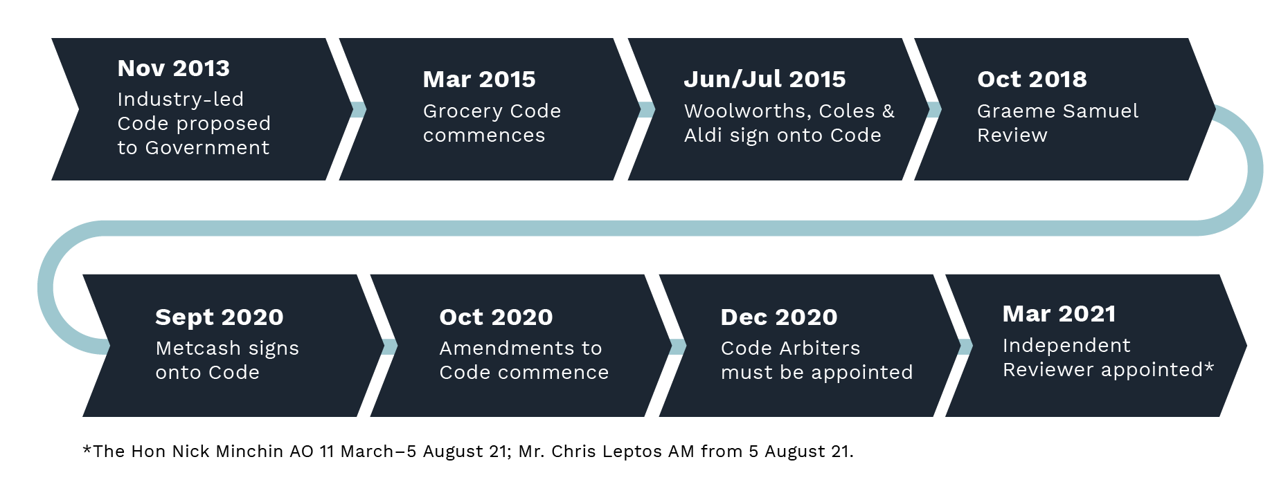

## Next review of the Code

There will be two upcoming reviews of the Code by the Australian Government.

* A review of the dispute resolutions provisions in the Code (including the role of the Code Arbiters and Independent Reviewer) must be commenced by 3 October 2022.
* A review of the operation of the remaining provisions of the Code must be commenced by   
  3 October 2023.

Each review must assess the impact of the Code in improving commercial relations between grocery retailers, wholesalers and suppliers.

# Coverage of the Code

## Retailers and wholesalers

Not all retailers operating in Australia are covered by the Code due to its voluntary nature. For example, Costco and Amazon are not signatories to the Code. Costco commenced Australian operations in 2009 and is positioned as an alternative to traditional supermarkets. Costco operates 10 stores across Australia and increased its market share in the last five years to 2.8%.[4]

Amazon operates in the food and grocery industry via the pantry food & pet supplies market, hosted on its Australian platform. As of September 2021, Amazon offers a range of dry foods such as snacks, cereals, condiments, tinned food and prepared meals, and beverages such as coffee, tea and soft drinks. Amazon does not yet offer fresh produce in Australia which, internationally, is offered under the AmazonFresh banner. Currently, Amazon accounts for only about 0.2% of market share in Australia.[5]

The Australian Government has included guidance in the Code that retailers and wholesalers that have an annual revenue of $5 billion or more, or a market share of 5% or more, should voluntarily sign up to the Code.[6] The Government continues to monitor industry participation in the Code to ensure that it delivers the appropriate policy objectives of supporting fair and reasonable commercial conduct.

## Suppliers

Suppliers are covered by the protections offered by the Code if they supply directly to a retailer or wholesaler that is a Code signatory. Suppliers that do not deal directly with Code signatories are not covered by the Code.

# Food & grocery sector in 2020/2021

The food and grocery industry in Australia is highly concentrated, with the four largest players – Woolworths, Coles, Aldi and Metcash – accounting for over 80 per cent of market share in 2020-21.[7]

The two largest retailers – Woolworths and Coles – account for over 65 per cent of industry revenue in the current year. Combined, the market share of these two major retailers has declined marginally over the past five years, mostly due to the growth of Aldi and Costco (9.8% and 2.8% of market share respectively).

|  |
| --- |
| *Key observations*  *At such high levels of market share, Woolworths and Coles enjoy a very high degree of bargaining power in commercial negotiations with suppliers.* |

Overall, industry revenue is expected to rise at an annualised 2.4% over the five years through 2021‑22, to $123.9 billion.[8]

**Food and grocery sector market share for financial year 2020-21[9]**

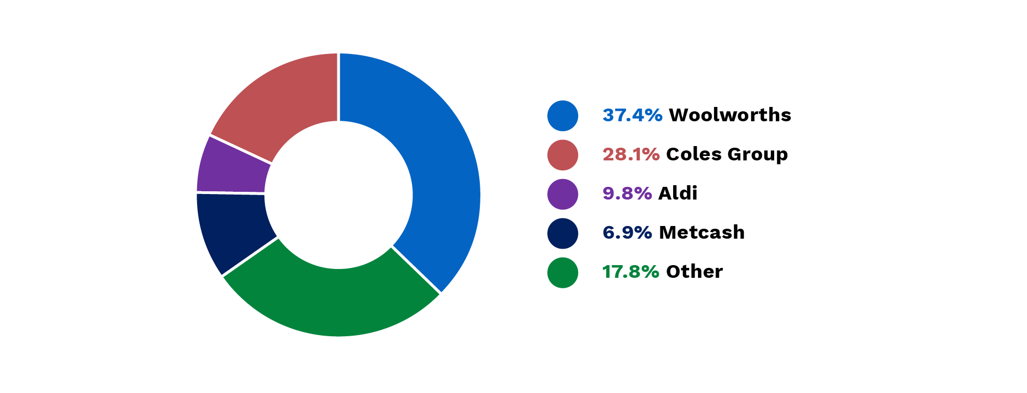

On the supply side, food and grocery manufacturing businesses range from multinational corporations with a host of brands to small family-owned businesses with a single product line. The industry was made up of over 16,000 businesses, employing over 270,000 people and contributing $132.7 billion to the Australian food and grocery manufacturing sector in 2019-20.[10]

## Competition in supermarket industry

While the Australian supermarket and grocery industry is characterised by a high level of concentration – industry reports[11] indicate that it remains highly competitive, with fierce competition among the major retailers.

Price-competitiveness and discounting remain a key feature of the retailers’ marketing strategy, as they compete to win Australian consumers who are highly price sensitive.

Over the past five years, the major retailers have also focused on other competitive factors in a bid to differentiate themselves from low-cost supermarkets. For example, Coles and Woolworths have increased their focus on improving the customers' shopping experience through store refurbishments, loyalty programs and online shopping capabilities.

## Impacts of COVID on the supermarket industry

The COVID-19 pandemic has resulted in increased demand by Australian consumers for food and grocery products sold by supermarkets over the past two years. This shift in household expenditure towards retail (rather than restaurants) has occurred due to continued restrictions on many services industries, notably the hospitality sector.

Online sales, which have grown significantly as a share of supermarkets’ revenue over the past five years, accelerated during the COVID-19 pandemic. Lockdowns and health directives to limit trips from home during outbreaks have encouraged more consumers to take up online grocery shopping.

This sustained increase in demand for food and groceries has put significant pressure on supermarkets’ supply chains. Supermarkets have had to work closely with suppliers to ensure the availability of stock and minimise the impact of disruptions such as panic-buying and the temporary closure of retail stores due to cleaning or staff shortages.

These unique difficulties prompted the creation of the Supermarket Taskforce comprising representatives from government departments, regulators, supermarkets, and the grocery supply chain. In 2020, authorisation for supermarkets to coordinate with each other when working with manufacturers, suppliers, and transport and logistics providers was granted by the ACCC to ensure the fair and equitable distribution of food and groceries across Australia.[12] The ACCC granted re-authorisation to allow this coordination to continue throughout 2021.[13]

|  |
| --- |
| *Key observations*  *Great credit must go to the Code signatories, suppliers, and regulators who collaborated to maintain a full-range of groceries on supermarket shelves throughout the pandemic period. The Australian community owes them all a debt of gratitude. The combined efforts of all industry participants to support local communities during such unprecedented times is a true testament to capabilities and resilience of this vital Australian industry.* |

## Changes affecting the food and grocery sector

The retail food and groceries sector continue to be challenged by the effects of the COVID-19 pandemic. One of the effects of the pandemic reported by retailers and suppliers is the increased demand by consumers for supermarket products. While other related industries, such as hospitality, have been closed or operating at reduced capacity, consumers have increased purchases from supermarkets. The industry has had to adapt to this rise in demand, even while the future demand remains uncertain.

The COVID-19 pandemic has destabilised the global container freight supply chain. Delayed shipments and rapidly rising freight rates are putting intense pressure on Australian exporters and importers – including international food and grocery suppliers.[14] As increased freight rates, commodity prices, and other input costs, flow through the system, there has been pricing pressure on grocery suppliers and by extension on supermarkets.

Consumer’s growing interest in online sales is also a change requiring consideration by supermarkets and their suppliers. Retailers may need to consider whether they should shift their focus as they compete to attract consumers to their online platforms and delivery services as well as traditional retail stores. Competitive practices that are currently commonplace may also change as consumer preferences change, and this could impact some businesses’ operations and profitability.

Retailers also have higher community expectations on their businesses. Expectations have risen in relation to how a business conducts itself with regard to the ethical sourcing of products, support for local businesses, the impact it has on the environment, and the relationship it has with customers, suppliers and employees.

These concerns have the potential to impact and change the ways retailers and suppliers go about their business. Supermarkets may need to work collaboratively with suppliers to ensure the best outcomes for consumers in mutually agreeable ways.

# Reports of the Code Arbiters & Survey of Code signatories

## Key findings from Code Arbiters’ reports

The Code Arbiter for each Code signatory is required to submit a written report each year to the Independent Reviewer and the ACCC. The report must also be provided to the retailer or wholesaler, who must publish the report on the Code signatory’s website. All four reports have been published in line with this process.[15]

It is important that the Code Arbiters’ reports are publicly available, so as to provide a level of transparency and to build confidence in the role of the Code Arbiter.

The information provided by Metcash to its Code Arbiter under clause 27B of the Code appears not to fully comply with the reporting requirements in respect to providing information about price increases. The Metcash Code Arbiter report notes that this issue was caused by limitations with the IT system and has foreshadowed that Metcash will not be able to fully comply with the reporting obligations in 2022, for the same reason.

It is the responsibility of all signatories to ensure that they comply with the Code obligations. While it is recognised that Metcash is a new signatory to the Code (signed up on 30 September 2020), its reporting of price rise information appears to fall short of the requirements of the Code and this issue has been raised with the ACCC for its information and further consideration.

### Handling of complaints

The Code signatories must report to the Code Arbiter on the number and nature of complaints it has received. During the 2020-21 reporting period, Woolworths reported to the Code Arbiter one complaint raised by a supplier, and Coles reported three complaints. Metcash and Aldi reported no complaints raised by suppliers. The Woolworths complaint and two of the Coles complaints were in relation to the delisting of a product. The final complaint to Coles was in relation to contractual requirements to undertake an audit. All complaints were reported to have been resolved within 20 business days or extended with the permission of the supplier.

|  |
| --- |
| *Key observations*  *It is clear that there are very few complaints from suppliers being elevated to the Code Arbiters over the reporting period. There may be several explanations for this very low volume of complaints:*   1. *There have been very few complaints from suppliers that are relevant to the Code* 2. *the Code signatories have effective systems and processes in place to resolve disputes with suppliers before they become complaints* 3. *suppliers are not aware that complaints can be elevated to the Code Arbiter* 4. *suppliers are not inclined to elevate complaints to the Code Arbiter (for various reasons such as too much paperwork; fear of damaging the commercial relationship; fear of retribution; etc)* 5. *all of the above.* |

### Price rise negotiations

Requirements under the Code prescribe that Code signatories must report to the Code Arbiter on the number of price rise requests received from suppliers and information around the number of days taken to conclude a position.

* Woolworths received 237 notifications of a price rise request and entered into negotiations with 94 of them. Of these, 75 negotiations were not concluded within 30 days of the initial request being made. The most number of days Woolworths took to conclude its position on a negotiation, starting from the notification day for the relevant proposed price increase, was 87 days.
* Coles received 1,101 notifications[16] of a price rise request and entered into negotiations with 35. Of these negotiations, 32 did not conclude a position within 30 days. The most number of days Coles took to conclude its position on a negotiation, starting from the notification day for the relevant proposed price increase, was 107 days.
* Aldi received 45 notifications of a price rise request and did not enter into negotiations following the requests.
* Metcash appears to have failed to comply with clause 27B of the Code to provide information about price increase requests to the Code Arbiter. Metcash explained that although it had procured new systems to ensure its readiness to comply with the Code, it later identified that the data captured did not exactly correlate with the information required to be provided under clause 27B of the Code. Metcash has since chosen to undertake a separate process for collecting this information but, due to a delay in its implementation, does not expect to be able to comply fully with clause 27B for the 2021-22 reporting period. With the deployment of new systems in late 2021, Metcash have indicated that it will be able to provide at least 9 months of more complete data for the next Code reporting period.

## Commentary on retailer/wholesaler survey responses

The Code prescribes that the Independent Reviewer must conduct an annual survey of suppliers, retailers and wholesalers, starting from 2021. In September 2021, the Independent Reviewer surveyed the Code signatories for the 2020-2021 reporting period. The survey included questions relating to the suppliers, the impact of recent changes to the Code, and the impact of COVID-19.

*Impacts of COVID-19 on supply chains and Code signatories’ relationships with suppliers*

Signatories identified the products that exhibited the most supply chain stresses during the 2020-21 reporting period, with some variation across Code signatories. The most common products identified were cleaning products, commodity-based food products (such as flour, sugar, pasta and rice), fresh meat, frozen fruit and vegetables, eggs, paper goods and medicinal products.

All Code signatories reported assisting suppliers with cashflow through adjustments to payments, contractual requirements or by providing direct assistance. Each signatory provided support in the following ways:

* Aldi amended its payment times and delivery requirements for certain suppliers, assisted with freight and absorbed some costs.
* Coles provided support to suppliers through Minimum Life on Receipt relief, transport, pallets, additional space in distribution centres, technical support and removal of promotions with supplier consent to protect volume for customers.
* Metcash worked with suppliers to adjust planned programs of promotional activity, change delivery patterns, and manage demand from across the network.
* Woolworths Food Company made approximately $20 million in advanced prepayments, temporarily shortened payment terms and made mutually agreed variations to contractual requirement for certain suppliers.

|  |
| --- |
| *Key observations*  *The Code signatories reported a substantial improvement in their relationships with suppliers resulting from their close collaboration throughout the 2020-21 reporting period.* |

### Impacts of changes to the Code

A number of changes to the Code came into effect during the 2020-21 reporting period.[17] The Code signatories noted that they had responded to these changes, including by appointing a Code Arbiter and implementing the new external dispute resolution processes, as well as complying with additional reporting responsibilities and requirements to complete business as usual activities within specified time frames.

The Code’s changes appear to have imposed varying degrees of additional administrative and compliance burden on Code signatories, including requiring new processes to be integrated with existing internal systems. Metcash, as the newest signatory, conducted a significant change management program to enhance its systems capability to meet both longstanding and new Code requirements. However, while systems have improved across the board, all Code signatories noted the outstanding difficulties with recording complaints and issues raised at the buying team level and that issues continue to be recorded predominantly after they are escalated internally. Work will need to continue to ensure all complaints and related issues brought by suppliers are comprehensively captured.

|  |
| --- |
| *Key observations*  *In general, Code signatories advised that the changes have had a positive impact on their relationship with suppliers despite the additional administrative burden.* |

### Staff training on the Code

Signatories reported that training on the Code is a requirement for employees that interact directly with suppliers such as buying teams. This training was generally required to have taken place within 20 to 28 days of a new employee’s commencement date. Woolworths also noted that it had extended some training on the Code to include all staff.

All Code signatories reported conducting a minimum of face-to-face training on the Code as well as the provision of additional training and materials. For example, Aldi, Coles and Woolworths also provide compliance training and guidance materials to relevant employees, and training offered by Metcash, Coles and Woolworths includes a mandatory online learning module. Completion of training, including compulsory components, generally occurred on an annual basis for relevant staff.

# Survey of suppliers to Code signatories

*“The retailers' success and the suppliers' success is tied together. Retailers and suppliers can only remain competitive through cooperation. While short-term pressures often point to "those who negotiate best, win", this has been proven to be unsustainable. The most compelling consumer products and business plans are borne out of collaboration and trust. For most consumer-packaged-goods companies today, suppliers cannot succeed without retailers, or retailers without suppliers.”*

John McLoughlin, CEO of the Advantage Group

## Process for conducting the survey

The Independent Reviewer provided the survey to 100 per cent of Code signatories’ suppliers. The survey was developed and delivered by Treasury in its role as the secretariat for the Independent Reviewer, in consultation with key stakeholders. The survey was accessible on Treasury’s website, and suppliers were provided two weeks to respond from 1 October 2021.

|  |
| --- |
| *Key observations*  *Surveying 100 per cent of the suppliers operating under the Code via an independent and confidential process is a significant and important milestone for the sector, and will be repeated in 2022.* |

This survey was achieved with the cooperation of the Code signatories, who all agreed to send the survey website link to every supplier on their email distribution lists. The ACCC and ASBFEO also contributed to raising awareness of the survey among small business suppliers to enhance participation rates.

The survey asked for suppliers’ feedback on the effectiveness of the Code, and how their retailer/wholesaler had conducted themselves throughout the 2020-21 reporting period. Questions were on topics such as suppliers’ dealings with retailers/wholesalers when an issue arose, the types of issues encountered, and suppliers’ experiences with internal and external dispute resolution processes.

The following information provides highlights from the survey findings, a more complete and confidential analysis of the results and supplier feedback will be provided to each Code signatory for them to assess their performance relative to their peers.

A total of 458 suppliers responded to the survey with many suppliers providing a response for more than one retailer, taking the total number of responses to 1082. Response rates as a proportion of the supplier contacts sent the survey varied with Aldi having the highest response rate and Coles having the lowest response rate.

Table 1. Responses as a proportion of Code signatories’ contacts

|  |  |  |  |  |
| --- | --- | --- | --- | --- |
| Signatory | Responses per retailer/wholesaler | Supplier contacts sent survey | Responses as a proportion of supplier contacts (%) | Number of suppliers per retailer/wholesaler |
| Woolworths | 313 | 2115 | 15% | 1152 |
| Coles | 306 | 5327 | 6% | 2114 |
| Metcash | 256 | 3869 | 7% | 1375 |
| Aldi | 207 | 828 | 25% | 828 |

### 

### Characteristics of respondents

Responses were received from suppliers that had a turnover below $1 million, all the way up to suppliers with a turnover over $1 billion. The largest proportion of respondents indicated their turnover was between $10 million and $50 million.

Many respondents reported more than one product type which they supply to their retailer/wholesaler. A large proportion of respondents supplied an Ambient (e.g. shelf-stable foods) or Chilled product while Pharmaceutical suppliers made up the lowest proportion of responses.

## Key findings

The survey identified that the number of suppliers reporting serious concerns was generally low, as a proportion of the number of responses per retailer, however the overall results should signal to Code signatories that action may be needed to improve their relationships with suppliers:

### Fair dealings with retailers and wholesaler

* 81 per cent of the responses indicated that suppliers were always or mostly treated fairly and respectfully by their retailer/wholesaler
* 16 per cent identified that their retailer or wholesaler acts unreasonably at times.
* 2 per cent identified that their retailer frequently acts unreasonably or with duress.

The breakdown of respondents’ answers by retailer/wholesaler is shown in Figure 3.

|  |
| --- |
| *Key observations*  *If there was an award for which Code signatory ‘always treats suppliers fairly and with respect’, the winner would be Aldi – by a considerable margin.* |

### Supplier issues resolved promptly

Suppliers that responded to the question on whether their retailer/wholesaler takes prompt, constructive action to resolve issues they have raised, reported that Aldi was the retailer most likely to take action with 88 per cent of Aldi respondents saying it always or usually took action to resolve issues. Between 66 and 71 per cent of suppliers to Woolworths, Coles and Metcash who provided survey responses reported the same.

### Conduct experienced from the retailers and wholesaler

Suppliers were asked to identify any issues they had experienced, as covered by the Code, with their retailer/wholesaler during the 2020-21 reporting period. Figure 5 shows the proportion of responses by suppliers for each issue.

For the 17 issues that could be selected (with suppliers able to select none or all issues), a greater proportion of suppliers to Coles and Woolworths identified such issues compared to suppliers of Metcash or Aldi (with a few exceptions). For example:

* a higher proportion of Coles and Woolworths suppliers reported experiencing delisting without being provided reasonable notice, or without a genuine commercial reason, or as a result of a complaint or dispute raised
* a higher proportion of Metcash suppliers identified late payments and deductions of invoice/remittance without consent.

### Raising supplier complaints

On average, approximately 23 per cent of respondents said there were no impediments to raising an issue or concern with their retailer/wholesaler’s buying team.

Of the suppliers that identified impediments to raising an issue with the buying team, fear of damaging a commercial relationship and fear of retribution were the most common answers.

Over 40 per cent of supplier respondents to Woolworths and/or Coles identified fear of damaging a commercial relationship as a key impediment, compared to 26 per cent of Metcash supplier respondents and 23 per cent for Aldi supplier respondents.

|  |
| --- |
| *Key observations*  *Around 30 per cent of Woolworths and Coles respondents identified “fear of retribution” as a key impediment to raising an issue under the Code with the buying team. This number dropped to 17 per cent for Metcash respondents and 11 per cent for Aldi respondents.* |

Responses from suppliers were almost identical when asked to identify the key impediments to raising a complaint with the Code Arbiter.

Proportionally, the reasons provided by suppliers in relation to key impediments to raising a complaint with the Code Arbiter were very similar to the results for raising an issue with the retailer/wholesaler’s buying team.

Notably, significantly more respondents to the survey reported not knowing who the Code Arbiter is or how to contact the Code Arbiter than those which reported they did. This indicated that while signatories have reported making an earnest effort to raise awareness of the Code Arbiter among suppliers, there remains an awareness gap that needs to be addressed.

### Awareness of the role of the Independent Reviewer

|  |
| --- |
| *Key observations*  *Almost half of suppliers reported they were not aware that they could request an independent review of the Code Arbiter’s process by the Independent Reviewer.* |

When asked whether they would consider bringing a complaint to the Independent Reviewer for review, almost half of respondents answered that they would not.

Key impediments to bringing a complaint to the Independent Reviewer for review are shown in Figure 7. Around a quarter of respondents chose not to provide a response.

## 

## Overall observations:

This annual survey is a first for the industry – it is a first of its kind to be conducted across all of the suppliers to the major retailers and wholesaler – representing an independent source of data for the industry and other stakeholders.

The good news is that the survey provides a strong indication that conduct within the industry is generally good and that fewer suppliers have reported experiencing the types of unacceptable buyer behaviours that were present in the industry prior to the Code’s introduction in 2015. The Code has contributed significantly towards improving commercial dealings in the industry.

Feedback through the survey suggests that the supplier experience in dealing with the two major supermarkets, Coles and Woolworths, is broadly similar. There are opportunities for both major retailers to lift their game by paying close attention to what their suppliers have raised in this survey – particularly buyer behaviours that may fall short of the obligations in the Code.

Suppliers have reported experiencing issues with lack of clarity of ranging principles, cancellation of orders, late payments and delisting without genuine commercial reasons. There is further concern with the reports of retrospective variations of grocery supply agreements – a practice that has since been prohibited in the Code following recent amendments that took effect on 3 October 2020. While overall the reported instances of these behaviours may be relatively low, the results of the survey provide an early signal of issues that may warrant closer attention by the major retailers across their buying teams.

Metcash, the newest signatory to the Code received feedback from its suppliers that identified deductions off invoices without consent and late payments as significant issues that were experienced on a disproportionate level compared to other signatories. These issues are of major concern given that cashflow is vital for small business suppliers, particularly during the recent COVID‑19 pandemic. Metcash still has much work to do in these areas as well as implementing appropriate systems to comply with the price rise reporting requirements under the Code.

Aldi deserves special recognition – receiving positive supplier feedback and outperforming the other signatories across many of the survey questions. Particularly encouraging is suppliers’ feedback in relation to Aldi’s transparency and certainty in contractual arrangements. It should be noted that Aldi’s business model differs from the major retailers – it offers a lower range of products to consumers (including fewer brand label products) and a less complex sourcing strategy. For example, Aldi agreements do not generally contain additional complexities such as discounts, or promotional activities or margin enhancement payments etc. The majority of Aldi’s suppliers are also exclusive to Aldi and tend to be longer term commercial relationships. It should also be noted that Aldi’s business culture and core principles of simplicity, consistency and responsibility – appears to have flowed through to its day-to-day dealings with suppliers. There still remains opportunities for improvement for Aldi however – such as on the matter of late payments.

In relation to the dispute resolution process under the Code, it is perhaps too early to tell if the addition of the Code Arbiters and Independent Reviewer is working as intended. The introduction of these new roles is relatively new and there may be a lack of awareness and trust from suppliers at this time. Fear of damaging commercial relationships is a major concern from suppliers and likely a significant factor in preventing them from raising complaints at all.

Not acknowledging valid complaints, or tolerating unacceptable buyer behaviour, is not in the interest of the Australian food and grocery industry. Such behaviours can become systemic over time, causing harm to suppliers and leading to inefficiencies that are to the detriment of Australian consumers.

Suppliers must make their voices heard by utilising the mechanism afforded to them under the Code, including the Code Arbiter and Independent Reviewer roles that have built-in confidentiality safeguards to protect the suppliers’ identity throughout the process. Through participation in the annual survey and engagement with industry associations or other Government agencies – such as ASBFEO – suppliers can help monitor and identify emerging issues to be addressed before they become systemic. There is also further work for Independent Reviewer to bridge the awareness gap and build greater trust in the dispute resolution system.

This first annual survey marks the first regular ‘health check’ by the Independent Reviewer for the industry. Retailers, wholesalers and suppliers will need to collaborate (subject to competition laws) if they are to move towards a shared vision of sustainability, efficiency, fairness and growth in the industry.

## What’s Planned for 2022

The Independent Reviewer’s forward plan for the 2021-2022 reporting period will focus on collaboration with industry participants and key stakeholders to promote the objectives of the Code and drive positive cultural change within the industry.

**For the Code signatories ...**

* Each Code signatory will be provided with a more complete and confidential analysis of their survey feedback, relative to their peers, to assist them in identifying and considering potential buyer behaviours that may need addressing.
* The 2022 Annual Report will include a commentary outlining any measures that the Code signatories have taken to address feedback from suppliers.
* All of the of Code signatories will be asked to participate in the 2022 survey.

**For the Code Arbiters ...**

* A workshop for the Code Arbiters will be scheduled to exchange views on good practice for resolving complaints under the Code.
* The 2022 Annual Report will include a commentary on what each Code Arbiter is doing to improve their practices in dispute resolution under the Code.

**For the Suppliers ...**

* Explore options for conducting Deep Dive workshops to better understand supplier concerns within the commercial relationship, with findings to be reported in the 2022 Annual Report.
* The 2022 annual survey of suppliers will seek feedback from 100% of suppliers that supply directly to the Code signatories.

**For the Independent Reviewer ...**

* Meet with the CEO of each Code signatory to provide and receive candid feedback on their organisation’s performance, and to discuss potential improvements to the Code.
* Participate in stakeholder forums and events to raise awareness of the Code Arbiter, Independent Reviewer and dispute resolution pathways available under the Code.
* Publish the 2022 Annual Report.
* Consider requests from suppliers to review a Code Arbiter’s process in dealing with complaints.
* Launch a new website to provide useful information and access to suppliers to lodge their requests for review of complaints with the Independent Reviewer.

1. Food and Grocery Code Independent Reviewer, <https://treasury.gov.au/food-and-grocery-code-independent-reviewer> (accessed 25 October 2021).
2. *Competition and Consumer (Industry Codes—Food and Grocery) Regulation 2015*, <https://www.legislation.gov.au/Details/F2021C00201>, (accessed 25 October 2021).
3. The Government noted recommendation 7 of the Samuel review report, which proposed that the ACCC consider adopting a collaborative approach with signatories, Code Arbiters and the Independent Reviewer to encourage more active compliance with the Code.
4. IBISWorld, AU Industry (ANZSIC) Report G4111: Supermarkets and Grocery Stores in Australia, Sept 2021.
5. Ibid.
6. *Competition and Consumer (Industry Codes—Food and Grocery) Regulation 2015*, <https://www.legislation.gov.au/Details/F2021C00201>, (accessed 25 October 2021), section 4.
7. IBISWorld, AU Industry (ANZSIC) Report G4111: Supermarkets and Grocery Stores in Australia, Sept 2021.
8. Ibid.
9. Ibid.
10. Australian Food and Grocery Council: State of the Industry Report 2019-20.
11. IBISWorld, AU Industry (ANZSIC) Report G4111: Supermarkets and Grocery Stores in Australia, September 2021.
12. Australian Competition and Consumer Commission (ACCC), Media release: Supermarkets to work together to ensure grocery supply, 24 March 2020; ACCC, Media release: Supermarkets authorised to continue cooperating on COVID-19 response, 3 September 2020.
13. ACCC, Media release: ACCC authorises ongoing cooperation between supermarkets on COVID-19 response, 25 August 2021.
14. Australian Competition and Consumer Commission, Media release: Global container trade disruptions leave Australian businesses vulnerable, 4 November 2021 (<https://www.accc.gov.au/media-release/global-container-trade-disruptions-leave-australian-businesses-vulnerable>).
15. Helen McKenzie, Code Arbiter 2020-21 annual report for Woolworths, <https://www.woolworthsgroup.com.au/icms_docs/195970_woolworths-group-code-arbiter-report.pdf>; Jeff Kennett, Code Arbiter 2020-21 annual report for Coles, [https://www.supplierportal.coles.com.au/wps/wcm/connect/6a623257-19d3-4096-b169-db9fdb8bb412/Code+Arbiter+Annual+Report+FY21.pdf](https://www.supplierportal.coles.com.au/wps/wcm/connect/6a623257-19d3-4096-b169-db9fdb8bb412/Code+Arbiter+Annual+Report+FY21.pdf?MOD=AJPERES&CACHEID=ROOTWORKSPACE-6a623257-19d3-4096-b169-db9fdb8bb412-nHyM1Hb); Martin Shakinovsky and Deborah Ziegler, Code Arbiter 2020-21 annual report for Metcash, [Metcash_Code_Arbiter_Annual_Report_Financial_Year_Ended_30_June_2021.pdf](https://s3.ap-southeast-2.amazonaws.com/static.metcdn.com/terms_of_trade_documents/Metcash_Code_Arbiter_Annual_Report_Financial_Year_Ended_30_June_2021.pdf); Bronwyn Gallacher, Code Arbiter 2020-21 annual report for Aldi, <https://corporate.aldi.com.au/fileadmin/fm-dam/pdf/Suppliers/2021/ALDI_Australia_Code_Arbiter_Annual_report_20-21.pdf>.
16. Coles’ reported figures included 724 fresh fruit and vegetable price negotiations.
17. Minister Michael Sukkar, [Media release: A better deal for food and grocery suppliers, https://ministers.treasury.gov.au/ministers/michael-sukkar-2019/media-releases/better-deal-food-and-grocery-suppliers](http://tweb/sites/mg/sbccpd/comp/400%20Codes%20of%20conduct/440%20Grocery%20Code/Government%20response%20to%20Samuel's%20Review/Independent%20Reviewer/Annual%20surveys/2021%20Annual%20Survey/Supplier%20survey%20results%20and%20analysis/Media%20release:%20A%20better%20deal%20for%20food%20and%20grocery%20suppliers,%20https:/ministers.treasury.gov.au/ministers/michael-sukkar-2019/media-releases/better-deal-food-and-grocery-suppliers), 2 October 2020.