**CODE ARBITER FOR ALDI 2023-24 ANNUAL REPORT**

# Introduction

As a signatory of the Food and Grocery Code of Conduct (Code) prescribed under the *Competition and Consumer Act 2010* (Cth), ALDI Stores (A Limited Partnership) ABN 90 196 565 019 (**ALDI**) is required under the *Competition and Consumer (Industry Codes – Food and Grocery) Regulation 2015* (**Regulation**) to appoint a Code Arbiter in relation to the Code.

On 3 October 2020, when the amendments to the Code came into effect, I was appointed by ALDI as its Code Arbiter.

# Annual reporting requirements

As the Code Arbiter for ALDI, I am required under the Regulation to prepare a written report in respect of each financial year. This is the fourth consecutive year I have prepared an annual report in the capacity of Code Arbiter for ALDI.

Clause 36D of the Regulation outlines the content requirements of the report by the Code Arbiter.

# Time frame

The Code Arbiter for ALDI is required to prepare the report and give copies to ALDI, the Australian Competition and Consumer Commission (**ACCC**) and the Independent Reviewer within 30 business days after the end of each financial year.

I confirm that I completed my report for the 2023-24 financial year on 21 July 2024. I also confirm that copies of my report were provided to the ALDI, the ACCC and the Independent Reviewer on 21 July 2024

# 2023-24 Report

This report is verified to be accurate for the purposes of annual reporting by the Code Arbiter for ALDI.

## Complaints received for investigation in the financial year

Under subclause 36D(2)(a)-(e) of the Regulation, the Code Arbiter for ALDI is required to report on the complaints received for investigation in the financial year.

The table below provides a summary of the numerical data on the complaints received in the 2023-24 financial year.

## Table 1. Complaints received for investigation by the Code Arbiter for ALDI in the 2023-24 financial year

|  |  |  |  |  |
| --- | --- | --- | --- | --- |
| **Nature of complaint** | **Time taken to investigate** | **Outcome of investigation** | **Resolved to satisfaction of**  **complainant** | **Number of complaints**  **2023-2024** |
|  |  |  |  |  |
| **Total** | | | | **0** |

I confirm that I did not receive any complaints made by suppliers for investigation in the 2023- 24 financial year.

## Number of complaints in relation to which a recommendation was made under subclause 36(4) (about paying compensation in excess of $5 million)

Under subclause 36D(2)(f) of the Regulation, the Code Arbiter for ALDI is required to report on the number of complaints in relation to which a recommendation was made under subclause 36(4) (about paying compensation in excess of $5 million).

I confirm that there were no complaints in relation to which I made a recommendation under subclause 36(4) (about paying in excess of $5 million) in the 2023-24 financial year.

## Information given to the Code Arbiter for ALDI by ALDI under clause 27B (information about price increases)

Under subclause 36D(2)(g) of the Regulation, the Code Arbiter for ALDI is required to report on any information given by ALDI under clause 27B (information about price increases).

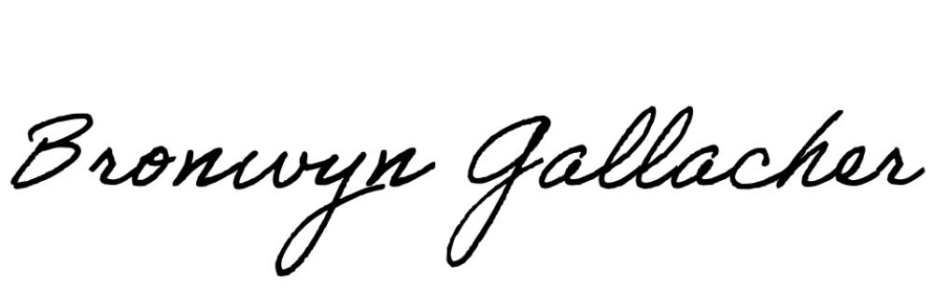I confirm that ALDI provided me with the following information under clause 27B (information about price increases) for the 2023-24 financial year:

|  |  |
| --- | --- |
| **Subclause** | **Total number** |
| 27B(a) – the total number of notifications given under subclause 27A(2) by ALDI to any supplier during the financial year | **837** |
| 27B(b) – the number of those 837 notifications that were not given within the 30-day period required by that subclause | **0** |
| 27B(c) – the total number of negotiations entered into during the financial year following requests made under subclause 27A(3) | **1** |
| 27B(d) – the number of that 1 negotiation in which ALDI did not conclude its position on the negotiations within the period of 30 days starting on the day (the notification day) the retailer or wholesaler was notified of the relevant proposed price increase by the supplier | **0** |
| 27B(e) – for each of the negotiations to which paragraph (d) applies, the number of days that ALDI took to conclude its position on the negotiations starting from the notification day for the relevant proposed price increase. | **N/A** |

**Signed by:**

Bronwyn Gallacher

**Managing Director and Principal Lawyer – CCL Consultants Pty Ltd**