**COLES FOOD & GROCERY CODE ARBITER ANNUAL REPORT**

**– FINANCIAL YEAR 2023-2024**

This report is provided in accordance with clause 36D of the Food and Grocery Code of Conduct (**Code**) by Jenny Linsten, Code Arbiter for Coles and its suppliers.

As I was appointed by Coles to the Code Arbiter role with effect from 15 February 2024, this report also

incorporates information provided by the Hon Jeffrey Kennett AC for the period 1 July 2023 to 14 February 2024 during which he was appointed by Coles as its Code Arbiter.

# Number of complaints received for investigation in the financial year

There were no complaints directed to the Coles Code Arbiter under clause 34(1) of the Code.

# Number of complaints for which a recommendation under subclause 36(4) of the Code was made

None.

# Information provided to me by Coles under clause 27B of the Code (Information about price increases) in relation to the financial year

I have set out below the information about price increases for the 2023-2034 financial year provided to me by Coles on 31 July 2024.

# Observations from my first five months in the Code Arbiter role

At the commencement of my appointment, I introduced a new complaints handling procedure for complaints made by suppliers under clause 34(1) of the Code and worked with Coles to make it easier for suppliers to find my contact details and the complaints handling procedure by updating and simplifying the complaints

handling area of the Coles Supplier Central portal.

At the same time, I sent a letter to all suppliers (which is also accessible on the Coles Supplier Central portal) to:

* introduce myself;
* assure them that I recognise that to be effective in my role, it is essential that I demonstrate that I am genuinely independent of Coles;
* outline the mechanisms in place to give them confidence that any discussions we have will remain strictly confidential and will not be shared with Coles without their clear instruction; and
* let them know that I am able to receive and respond to informal complaints or requests for assistance about matters covered by the Code or other inappropriate conduct by Coles or any of its team members without the need for them to make a formal complaint under clause 34(1) of the Code.

I have also undertaken a range of activities and spoken to a broad range of people to ensure that I understand the complex relationships between Coles, its suppliers and other supermarket industry stakeholders and can leverage that understanding for the benefit of Coles suppliers.

To date, I have:

* Familiarised myself with the Coles processes, procedures and staff training materials that touch on the requirements of the Code;
* Requested and received briefings from Coles management on areas of key focus for suppliers

including cost price increase requests, range review processes and outcomes, payments procedures and queries, current supplier programs and Fresh supplier forecasting, ordering and purchasing processes;

* Met with the Coles CEO, Chief Commercial Officer and the General Managers for each Fresh and Grocery business unit to discuss my plans for the Code Arbiter role and build constructive

relationships that will enable me to openly and frankly communicate any issues I identify so they can be promptly addressed for the benefit of Coles suppliers;

* Addressed a town hall meeting of Coles Category Managers and a Fresh supplier forum to introduce myself and reinforce the important role the Code plays in ensuring that the relationship between Coles and its suppliers is conducted fairly and transparently;
* Participated in a Q&A video with Coles Chief Commercial Officer which was circulated to Coles suppliers to personally introduce myself and encourage them to contact me if they would like to confidentially discuss any queries or concerns they have about their dealings with Coles;
* Held meetings with a range of industry associations and consultants that represent Coles suppliers across both the Fresh and Grocery product categories to obtain feedback on particular areas of focus for the suppliers they represent;
* Spoken directly with a range of Coles suppliers at both Coles and industry sponsored conferences, meetings and events;
* Established constructive relationships with the Code Independent Reviewer Chris Leptos AO and the other Code Arbiters to stay up to date with current topics of relevance to us all; and
* Established regular, on-going meetings with the Coles CEO, Chief Commercial Officer and GM – Risk & Compliance to ensure that I have:
  + access to the information and Coles team members I need to carry out my role; and
  + a regular forum in which to provide open and constructive feedback to senior Coles management so that concerns I have identified can be promptly addressed.

While neither I nor Coles’ previous Code Arbiter received any formal complaints from suppliers under clause 34(1) of the Code during the 2023-24 financial year, as noted above I am also authorised by Coles to receive and act on concerns raised by suppliers without the need for a formal or written complaint to be made. I feel strongly that the ability of suppliers to have these informal, no-cost discussions with me has the potential to deliver significant benefits to both individual suppliers and the broader Coles supplier base.

Since my appointment, I have been informally contacted by eleven suppliers or their representatives for assistance with a broad range of queries and concerns involving initial product ranging procedures, range review outcomes, payments system processes and other aspects of the relationship between Coles and its

suppliers. Some suppliers who sought my advice or feedback did not want their individual concerns raised with Coles while others requested my support to raise their concerns directly with Coles senior management.

There have been a range of positive outcomes, for both individual suppliers and the broader Coles supply base, arising from these informal contacts, including:

* Adjustment to aspects of individual range review outcomes and implementation processes;
* Updates to the processes, procedures and template documents provided to Coles category management teams to avoid recurrence of issues identified through my discussions with suppliers. These updates were related to range reviews, support for small suppliers and suppliers of imported products, and

procedures for the audit of supplier payments;

* Refinement to the existing process for Coles senior management oversight of ongoing relationships with suppliers who have raised complaints;
* Increased supplier confidence that their individual circumstances had been understood and considered before Coles made decisions that affected them; and
* Increased transparency of Coles’ rationale for the making of decisions affecting suppliers.

I have also been contacted by Coles suppliers, customers and other industry stakeholders who wished to

discuss matters that fall outside the scope of my role under the Code. While most of these contacts were able to be re-directed to alternative processes more suited to their situation, I am pleased to report that Coles has encouraged me to pass on non-Code related matters I become aware of that would allow them to identify areas where their processes should be improved or where suppliers or customers require additional support.

Where I have done this, Coles has acted promptly to address the issues identified and kept me updated on the progress they have made to resolve them.

I am optimistic that the relationships I have built, and will continue to build, with Coles suppliers, Coles senior management and industry stakeholders will enable me to assist Coles suppliers with any concerns they have, either by supporting them confidentially to raise those concerns with Coles or through raising them with Coles myself when requested by the supplier to do so.

Finally, I would like to thank the Coles suppliers and other industry stakeholders who have contacted me so far and generously shared their individual perspectives on how I can most effectively use my role to benefit all Coles suppliers. I have found these conversations incredibly valuable. I will continue to prioritise

gaining the trust of all Coles suppliers so that many more of them will have the confidence to speak directly with me as I continue in this role.

# Jenny Linsten

Code Arbiter for Coles and its suppliers 5 August 2024

# COLES COST PRICE INCREASE REQUEST REPORT FOR FINANCIAL YEAR 2023-2024 PROVIDED TO THE COLES CODE ARBITER UNDER 27B OF THE CODE

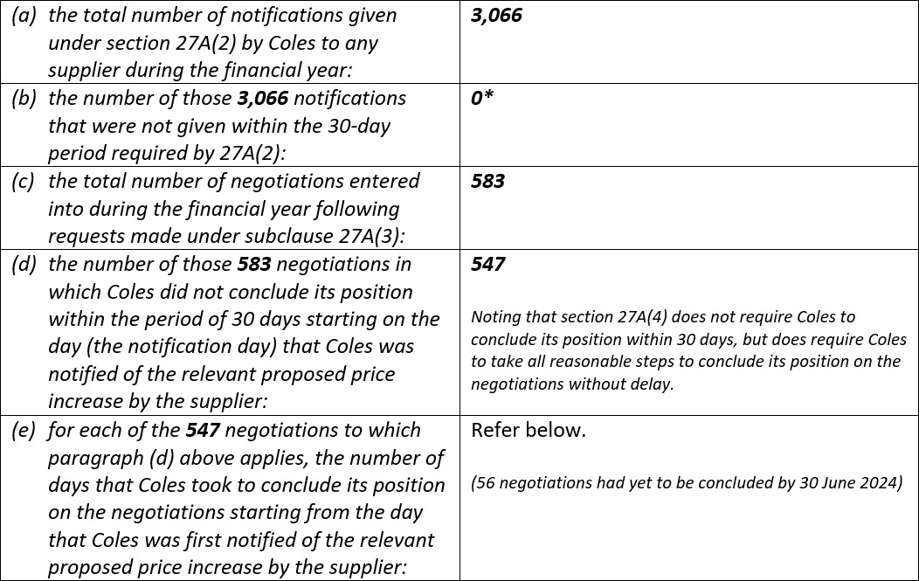

*\* There was one Cost Price Increase request where the supplier did not formally submit in*

*accordance with the Cost Price Alteration process. The Cost Price Increase process has been communicated to suppliers and therefore Coles does not consider that in this instance it was appropriately ‘informed’ of the request in accordance with s.27A(2).*

