© Commonwealth of Australia 2025

ISBN: 2653‑7133

This publication is available for your use under a [Creative Commons Attribution 4.0 International](https://creativecommons.org/licenses/by/4.0/) licence, with the exception of the Commonwealth Coat of Arms, the Treasury logo, photographs, images, third party materials, materials protected by a trademark, signatures and where otherwise stated. The full licence terms are available from [creativecommons.org/licenses/by/4.0/legalcode](http://creativecommons.org/licenses/by/4.0/legalcode).

Creative Commons attribution licence 3.0 icon. 

Use of Treasury material under a [Creative Commons Attribution 4.0 International](https://creativecommons.org/licenses/by/4.0/) licence requires you to attribute the work (but not in any way that suggests that Treasury endorses you or your use of the work).

**Treasury material used ‘as supplied’**

Provided you have not modified or transformed Treasury material in any way including, for example, by changing the Treasury text; calculating percentage changes; graphing or charting data; or deriving new statistics from published Treasury statistics – then Treasury prefers the following attribution:

Source: The Australian Government, the Treasury

**Derivative material**

If you have modified or transformed Treasury material, or derived new material from those of the Treasury in any way, then Treasury prefers the following attribution:

Based on the Australian Government the Treasury data Food and Grocery Code Independent Reviewer Annual Report 2023–24

**Use of the Coat of Arms**

The terms under which the Coat of Arms can be used are set out on the Department of the Prime Minister and Cabinet website (see [www.pmc.gov.au/government/commonwealth‑coat‑arms](http://www.pmc.gov.au/government/commonwealth-coat-arms)).

**Other uses**

Enquiries regarding this licence and any other use of this document are welcome at:

Manager  
Media Unit  
The Treasury  
Langton Crescent   
Parkes ACT 2600  
Email: [media@treasury.gov.au](mailto:media@treasury.gov.au)

In the spirit of reconciliation, the Treasury acknowledges the Traditional Custodians of country throughout Australia and their connections to land, sea and community. We pay our respect to their Elders past and present and extend that respect to all Aboriginal and Torres Strait Islander peoples.

# Contents

Foreword 1

Overview of the Code 3

Composition of supermarket sector 4

Reports of the Code Arbiters and survey of Code signatories 5

Key findings from Code Arbiters’ reports 5

Handling of complaints 5

Price increase notifications and resolution timeframes 6

Commentary on retailer/wholesaler survey responses 7

Relationship with suppliers 7

Dispute resolution 7

Training and compliance 8

Price increase notifications and negotiations 8

Cost effectiveness 9

Complaints reviewed in 2023–24 10

Survey of suppliers to Code signatories 11

Process for conducting the survey 11

Characteristics of respondents 12

Key findings from the survey of suppliers 13

Fair dealings with retailers and wholesalers 13

Supplier issues – resolutions 15

Retailer and wholesaler conduct 16

Raising an issue with a retailer/wholesaler 19

Bringing a complaint to the Code Arbiter 20

Bringing a complaint to the Independent Reviewer 21

Fear of retribution 21

Contracting out of Code obligations 22

Overall findings 23

Observations on the Code 24

Activities in 2024–25 25

# Foreword

I am pleased to present the Annual Report for 2023–24 prepared in accordance with my responsibilities as the Independent Reviewer under the Food and Grocery Code of Conduct (the Code).

Since my last report there has been an enormous public and regulatory focus on the conduct of supermarkets, and the impact they have on consumers and their suppliers. My role, and this report, is limited in scope to the relationship between the Code signatories (Aldi, Coles, Metcash and Woolworths) and their suppliers.

I form my views by engaging directly with the Code signatories, their Code Arbiters, and their suppliers. I also engage with peak industry groups such as the Australian Food and Grocery Council, the National Farmers’ Federation, and regional grower groups.

Most importantly, I conduct confidential ‘deep dive’ sessions with numerous suppliers to fully understand the nature of their relationship with the Code signatories.

In addition, I formally survey (in writing) the Code signatories and their suppliers.

On the Independent Reviewer’s website, I publish the following documents:

* Annual Report (incorporating feedback from suppliers and the Code signatories)
* Interactive dashboard (providing detailed analysis of supplier feedback)
* Reports from each of the 4 Code Arbiters.

Separately, I provide each Code signatory with detailed feedback from suppliers relating to their specific conduct.

This is a comprehensive exercise, and great effort is taken to de‑identify confidential information before sharing the significant insights from these processes.

The Code Arbiters have advised me that they received no formal complaints from the suppliers this financial year. However, several of them also highlighted the importance of maintaining the ‘informal’ complaints process, as it has been successful in improving the dialogue between suppliers and the Code Arbiters.

Based on the results of the supplier survey, I have compiled a ranking of the performance of the Code signatories. This information is again being made public to promote greater transparency and to foster greater competition in the sector:

|  |  |  |
| --- | --- | --- |
| 1st place | Aldi | (1st in 2022–23) |
| 2nd place | Metcash | (2nd in 2022–23) |
| 3rd place | Coles | (3rd in 2022–23) |
| 4th place | Woolworths | (4th in 2022–23) |

These rankings are based on 1,167 confidential survey responses from suppliers – the highest response rate since the supplier surveys commenced in 2021. I thank the suppliers for taking the time to participate in this important process.

Suppliers are always welcome to contact me via the website at [grocerycodereviewer.gov.au](https://grocerycodereviewer.gov.au), or via email at [fgc@treasury.gov.au](mailto:fgc@treasury.gov.au).

This will be my final report under the current Code, as the Code is scheduled to sunset (i.e. automatically repeal) on 1 April 2025. The new code, which implements the recommendations of the independent review into the Food and Grocery Code of Conduct, will come into effect on 1 April 2025.

Finally, I would like to record my personal thanks to the team in the Treasury’s Digital, Competition and Payments Division that provides me with important and timely secretariat support throughout the year.



**Chris Leptos** AO

Independent Reviewer

# Overview of the Code

The Code was introduced in 2015 as a voluntary code prescribed under the Competition and Consumer Act 2010and it is binding for its signatories*.* Its purpose is to address harmful practices in the grocery sector stemming from an imbalance of bargaining power between supermarkets and their suppliers. The Code has 4 objectives:

* to regulate standards of business conduct in the grocery supply chain and to build and sustain trust and cooperation throughout that chain
* to ensure transparency and certainty in commercial transactions in the grocery supply chain and to minimise disputes arising from a lack of certainty in respect of the commercial terms agreed between parties
* to provide an effective, fair and equitable dispute resolution process for raising and investigating complaints and resolving disputes arising between retailers or wholesalers and suppliers
* to promote and support good faith in commercial dealings between retailers, wholesalers and suppliers.[1]

Retailers and wholesalers in the food and grocery sector may sign up as signatories to be regulated by the Code. Woolworths Group (Woolworths), Coles Group Limited (Coles), Aldi Australia (Aldi), and Metcash Food and Grocery (Metcash or MF&G) have signed on as signatories and are liable for conduct not in accordance with the Code for the period in which they have signed.

The Government has initiated several reviews of the Code to ensure it is working in accordance with its initial intent.

In 2018, Professor Graeme Samuel AC, former Chair of the Australian Competition and Consumer Commission (ACCC) undertook a statutory review of the Code. The Government accepted 13 of Professor Samuel’s 14 recommendations, the most important of which were changes to the dispute‑resolution processes following a finding that the existing provisions were ineffective and underutilised by suppliers. These changes came into effect on 2 January 2021.

In September 2022, Treasury undertook a statutory review of the dispute‑resolution provisions in Part 5 of the Code, which formed the first part of the Code’s review. Treasury provided advice to Government on its findings in September 2023 and in January 2024, the Government released its final report of the review, with the Government’s response. The Government supported the review’s findings.

In 2024, the Government announced the appointment of Dr Craig Emerson to undertake an independent statutory review of the Code. On 24 June 2024, the Government released the final report of the review, with a response. The Government supported all 11 recommendations of the final report with the central recommendation that the Code be made mandatory with heavy penalties for breaches. The Government established the new code on 12 December 2024 and it will come into effect on 1 April 2025, when the current Code sunsets.

## Composition of supermarket sector

Figure 1: Food and grocery sector market share for 2024[2]

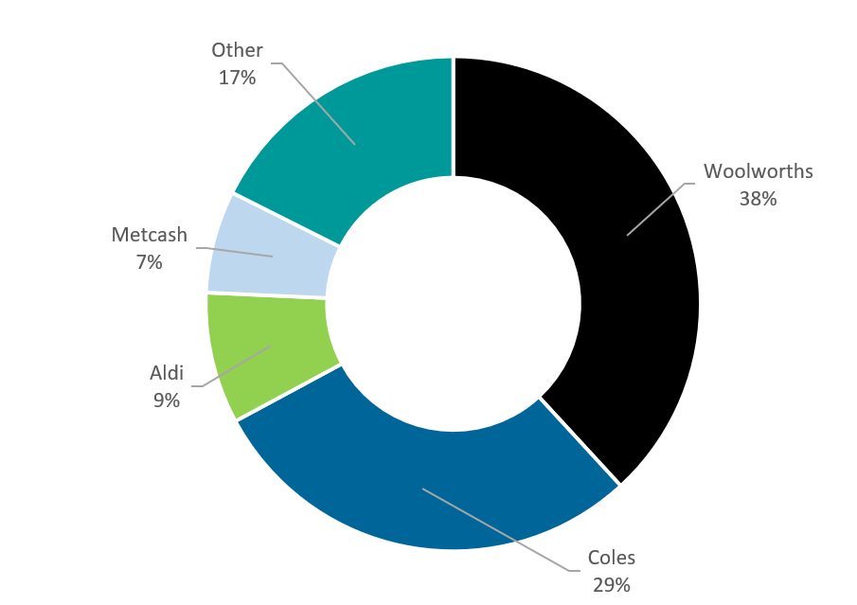

The supermarkets and grocery stores industry is made up of over 2,267 businesses, employing around 440,000 people.[3] Revenue was forecast to rise by an annualised 0.7 per cent to $131.7 billion over the 5 years to 2023–24 and revenue is expected to rise at an annualised 2.2 per cent to $147.1 billion over the 5 years through 2028–29.[4]

The 3 largest food and grocery retailers are Woolworths, Coles and Aldi, and the largest food and grocery wholesaler is Metcash. Together they held 82.5 per cent of market share in 2024,[5] as shown in Figure 1.

The food and grocery manufacturing sector (suppliers) in Australia generated $163 billion in sales and 280,000 jobs.[6]

# Reports of the Code Arbiters and survey of Code signatories

## Key findings from Code Arbiters’ reports

Code Arbiters must prepare a written report each financial year setting out the number of complaints received for investigation, the nature of the complaints, the outcomes, and a range of other information. Each Code Arbiter must provide a copy of their report to the retailer or wholesaler for publication on their website, the ACCC and the Independent Reviewer.

The Code Arbiters again reported that no formal complaints were made this financial year. Some Code Arbiters noted in their reports that while no formal complaints were received, the informal dispute resolution process introduced in 2022 is a critical avenue for suppliers raising issues and resolving disputes between suppliers and signatories. The Code Arbiter reports are available on the Independent Reviewer’s [website](https://grocerycodereviewer.gov.au/reports/code-arbiter-reports). The reports are also available on each of the signatory websites as required by the Code.

### Handling of complaints

Table 1 shows the number of complaints received by each Code Arbiter. There were no formal complaints made to the Code Arbiters in the 2023–24 financial year (FY).

Table 1: Number and nature of complaints

|  |  |  |  |  |
| --- | --- | --- | --- | --- |
| Code signatory | Number of formal complaints | | | |
| 2020–21 | 2021–22 | 2022–23 | 2023–24 |
| Woolworths[7] | 0[8] | 0 | 0 | 0 |
| Coles[9] | 3 | 2 | 0 | 0 |
| Metcash[10] | 0 | 0 | 0 | 0 |
| Aldi[11] | 0 | 0 | 0 | 0 |

### Price increase notifications and resolution timeframes

The retailer or wholesaler must report to the Code Arbiter on price increases, including the number of notifications retailers or wholesalers gave to suppliers in response to being informed of a price increase by suppliers, the number of negotiations entered into, and the time it took to conclude negotiations. [12] The number of price notifications dropped substantially across all retailers in 2023–24 and there was a notable increase in the proportion of price negotiations exceeding 30 days for Woolworths, Coles and Metcash.

* Woolworths gave 1,051 notifications (down from 2,049 in the 2022–23 FY) in response to being informed of a price rise increase from suppliers. All notifications were given within the 30‑day period required by subclause 27A(2) of the Code. Suppliers requested negotiations with respect to 707 of the 1,051 notifications. 592 negotiations (84 per cent, up from 70 per cent in the 2022‍–‍23 FY) were not concluded within 30 days of the request. Woolworths noted 44 negotiations had yet to be concluded by 30 June 2024.
* Coles gave 3,066 notifications (down from 3,804 in the 2022–23 FY). All notifications were given within the 30‑day period required by subclause 27A(2) of the Code. Coles entered 583 negotiations, of which 547 negotiations (94 per cent, up from 87 per cent in the   
  2022–23 FY) were not concluded within 30 days of the request. Coles noted 56 negotiations had yet to be concluded by 30 June 2024.
* Metcash gave 632 notifications (down from 1062 in the 2022–23 FY) in response to being informed of a price increase by suppliers, of which 6 were not given within the 30‑day period required by subclause 27A(2) of the Code. Metcash entered negotiations for 17 notifications, with all negotiations (100 per cent, up from 91 per cent in the 2022–23 FY) not concluding within 30 days.
* Aldi gave 837 (down from 1,396 in the 2022–23 FY) notifications. All negotiations were given within the 30‑day period required by subclause 27A(2) of the Code. Aldi entered into negotiations for one notification, and reported zero negotiations (the same as in the   
  2022–23 FY) not concluding within the 30 days.

The longest time taken to conclude negotiations was 244 days from Coles, excluding the 56 negotiations ongoing at the time the Coles Code Arbiter report was provided. While Woolworths reported that its longest negotiation took 200 days, and Metcash 154 days, Aldi did not exceed the 30‑day threshold for a single price notification negotiation.

The full Code Arbiter reports are available at [https://grocerycodereviewer.gov.au/reports/code‑arbiter‑reports](https://grocerycodereviewer.gov.au/reports/code-arbiter-reports).

## Commentary on retailer/wholesaler survey responses

In November 2024, the Independent Reviewer carried out the fourth annual survey of Code signatories under the Code. The survey was in relation to the 2023–24 reporting period and covered the following:

* Code signatories’ relationships with suppliers, including the effect of the Code and what the Code signatories would do differently in the absence of the Code.
* Dispute resolution, including how Code signatories have informed suppliers about formal and informal dispute resolution options.
* Training and compliance, including the type and frequency of training and how compliance is ensured.
* Price increase notifications and negotiations, including how Code signatories have endeavoured to process these requests in a timely manner and reasons for negotiations taking longer than 30 days.
* The cost effectiveness of the Code, including whether Code signatories consider the benefits outweigh the cost and what changes the Code signatories would recommend.

### Relationship with suppliers

The Code signatories reported having a positive relationship with their suppliers. The signatories expressed their strong commitment to maintaining positive relationships. Consistent with general industry feedback, Woolworths noted the expansion of Code Arbiters’ roles to include responding to informal complaints has been positive, leading to faster dispute resolution and improved supplier perceptions regarding raising issues with their Code Arbiter.

Some Code signatories indicated their behaviour would be unchanged in the absence of the Code given their commitments to positive relationships with suppliers and expressed concern that the introduction of a penalty regime as part of the mandatory Code may erode otherwise positive relationships between wholesaler and suppliers.

### Dispute resolution

Code signatories reported that their complaints handling procedures contain details of both formal and informal dispute resolution options available to suppliers. Code signatories noted that they have also provided information on dispute resolution to suppliers in other ways, including in newsletters, conferences, forums and presentations.

### Training and compliance

All Code signatories advised that their buying team employees undergo training upon commencement and annually. Some Code signatories noted additional components of their training programs. These included having the Code Arbiter conduct training, training for other staff (such as head office staff or replenishment and store operations staff), more frequent or detailed training for specific obligations (such as delisting), and ad hoc or refresher training forums. One Code signatory also noted that its training had been updated based on enquiries from the ACCC.

All Code signatories include assessments in the training programs. Coles advised that it requires employees to answer 90 per cent of questions accurately to pass their training program. Woolworths advised that it monitors assessment results, which are reported to its risk team.

Code signatories noted various means of monitoring compliance with the Code. These include automated reporting and monitoring in internal systems, as well as internal audits to assess compliance. Some Code signatories noted that they focus on key risk areas when assessing compliance, such as product delisting and price increase requests. Metcash advised that the learnings from compliance audits are used to enhance training and process documents.

Additionally, Woolworths stated that supplier feedback captured through surveys and listening sessions influences Woolworths’ compliance training and is used to identify areas where additional training or support may be required.

### Price increase notifications and negotiations

All Code signatories stated that they had dedicated resources to monitoring timelines for price increase requests, including automated processes, monitoring and reporting, manual follow‑ups, and increasing or reallocating staff. Some Code signatories noted that while price increase requests have recently reduced, such requests remain elevated.

ALDI reported that it had no instances where price increase negotiations took more than 30 days to conclude.[13] Other Code signatories reported circumstances where price increase negotiations took more than 30 days to conclude included cases where Code signatories undertook a commercial review of price increase proposals or requested additional information from suppliers, as well as cases where parties preferred to continue negotiating. Code signatories noted that the time taken by suppliers to respond to their requests is out of their control.

Code signatories also noted rapid changes in pricing in the current environment, and their need to balance expectations that suppliers are fairly paid against a desire for retail price increases for consumers to be minimised.

### Cost effectiveness

Aldi welcomed the implementation of the Food and Grocery Code review’s recommendations, and considered additional changes are unnecessary. Woolworths stated that under the current Code, the benefits of the Code exceed the costs. Regarding potential changes to the Code, several signatories questioned whether the benefits of the new mandatory Code would continue to outweigh the costs, particularly given the size of the penalties in the new Code.

# Complaints reviewed in 2023–24

Consistent with the previous year, the Independent Reviewer did not receive any supplier requests to review the complaints handling processes conducted by the Code Arbiters during the reporting period. A significant factor in these results may be the preference for suppliers to resolve disputes informally with Code signatories. Several Code Arbiters commented on the importance of informal dispute resolution in their 2023–24 annual reports.

Informal dispute resolution will continue to be available under the new code in addition to formal dispute resolution. The ACCC will also establish an anonymous complaints mechanism allowing suppliers and other industry stakeholders to report issues directly to the ACCC.

# Survey of suppliers

## Process for conducting the survey

The survey was accessible online from 22 October 2024 until 26 November 2024. At the request of the Independent Reviewer, the Code signatories sent the survey link to suppliers. Signatories sent the survey to the most appropriate contact for each supplier, to ensure that one response was provided per supplier in respect to each of the Code signatories.

The survey asked for supplier feedback on the effectiveness of the Code, and how the signatories conducted themselves throughout the 2023–24 reporting period during their commercial dealings. The questions covered topics such as suppliers’ dealings with their retailer/wholesaler when an issue arose, the types of issues encountered, and suppliers’ experiences with internal and external dispute resolution processes. Consistent with the recommendations of the Code’s review in 2024, the survey included new questions asking suppliers about their fear of retribution and experience of signatories requesting contract changes.

There was a marked increase in engagement with the annual supplier survey. A total of 500 suppliers responded to the survey – compared with 279 last year. Many suppliers provided responses for more than one retailer/wholesaler, taking the total number of unique responses to 1,167 compared with 651 last year.

Response rates as a proportion of the Code signatories’ supplier contacts is provided in Table 2.

Table 2: Responses as a proportion of Code signatories’ contacts

|  |  |  |  |  |
| --- | --- | --- | --- | --- |
| Signatory | Survey responses per retailer/wholesaler | Number of supplier contacts that were sent the survey | Survey responses as a proportion of supplier contacts sent the survey (per cent) | Number of suppliers per retailer/wholesaler |
| Woolworths | 345 | 2,701 | 12.7 per cent | 2,839[14] |
| Coles | 348 | 2,230 | 15.6 per cent | 2,230 |
| Metcash | 211 | 732 | 28.8 per cent | 2,744 |
| Aldi | 275 | 1,453 | 18.9 per cent | 1,615[15] |

For the second year, the data from these responses has been collated and transformed into a publicly available Power BI dashboard available at: [https://grocerycodereviewer.gov.au/reports/‌annual-reports/2023-24-annual-report](https://grocerycodereviewer.gov.au/reports/annual-reports/2023-24-annual-report). The aim of this is to allow the public the option to interrogate the results of the survey, beyond the findings that are captured in this report. The publication of how signatories ranked for each of the respective questions is intended to foster further competition in the sector.

### Characteristics of respondents

Responses were received from suppliers that had a turnover which ranged from less than $1 million to more than $1 billion, where the largest proportion of respondents had a turnover between $50 million and $250 million. Respondents with turnover less than $10 million, or more than $250 million have been aggregated in the survey dashboard.

When asked what product(s) they supplied, respondents often reported dealings in more than one product type. As seen in Figure 2, a large proportion of respondents supplied ambient (e.g. shelf‑stable foods) followed by chilled products, while pharmaceutical and pet food suppliers equally made up the lowest proportion of responses.[16]

Figure 2: Food and groceries supplier by respondents

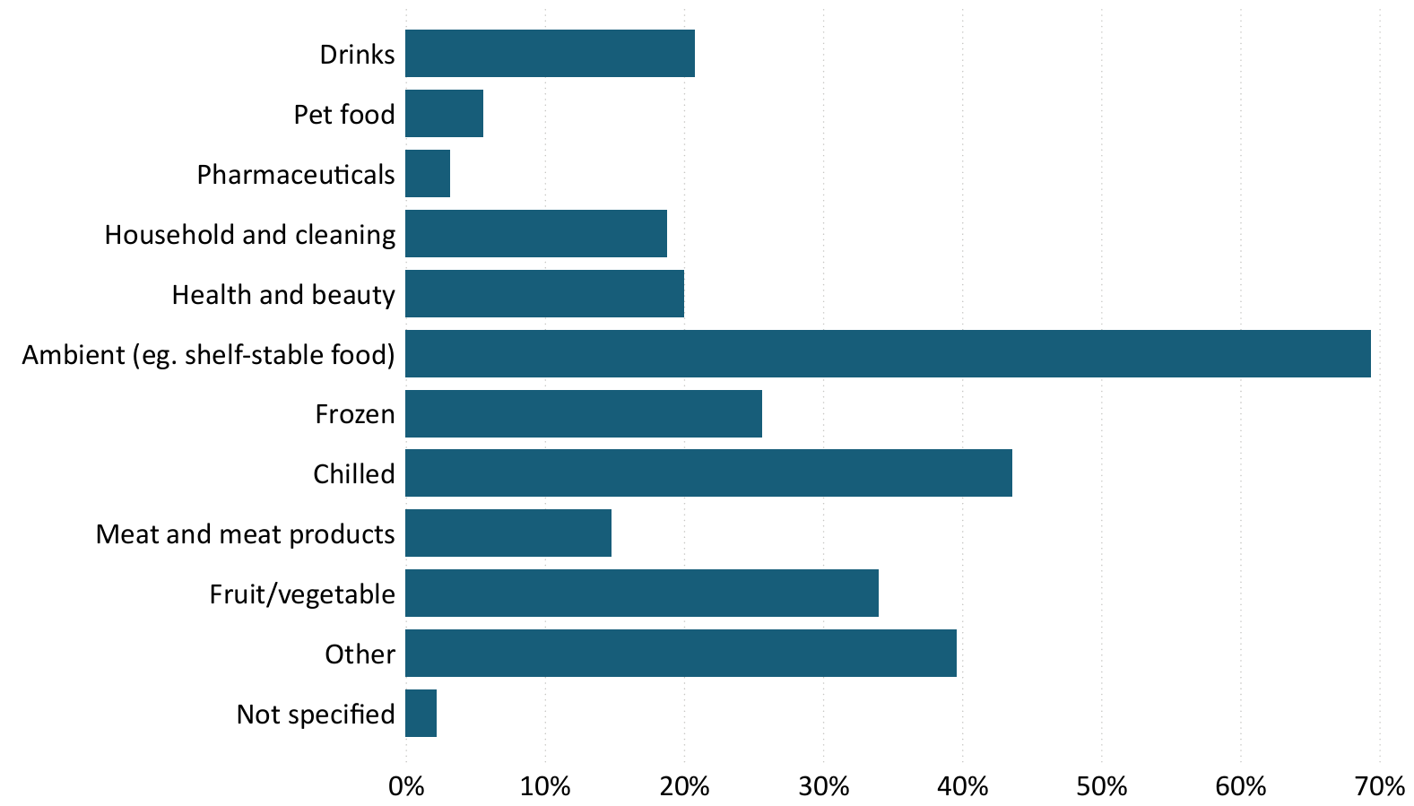

The make‑up of respondents for the 2023–24 survey is consistent with respondents to the survey in previous years.

## Key findings from the survey of suppliers

Consistent with last year’s report, signatories were ranked against their counterparts to assess who performed the best in each of the assessable questions asked of suppliers. Aldi ranked best across the board against other signatories, particularly outperforming in questions on supplier experience. To see how each of the signatories ranked in each of the measurable categories, explore the dashboard presenting the survey results at: [https://grocerycodereviewer.gov.au/reports/‌annual-reports/2023-24-annual-report](https://grocerycodereviewer.gov.au/reports/annual-reports/2023-24-annual-report).

### Fair dealings with retailers and wholesalers

Figure 3: Fair and reasonable dealings of retailer/wholesaler towards suppliers

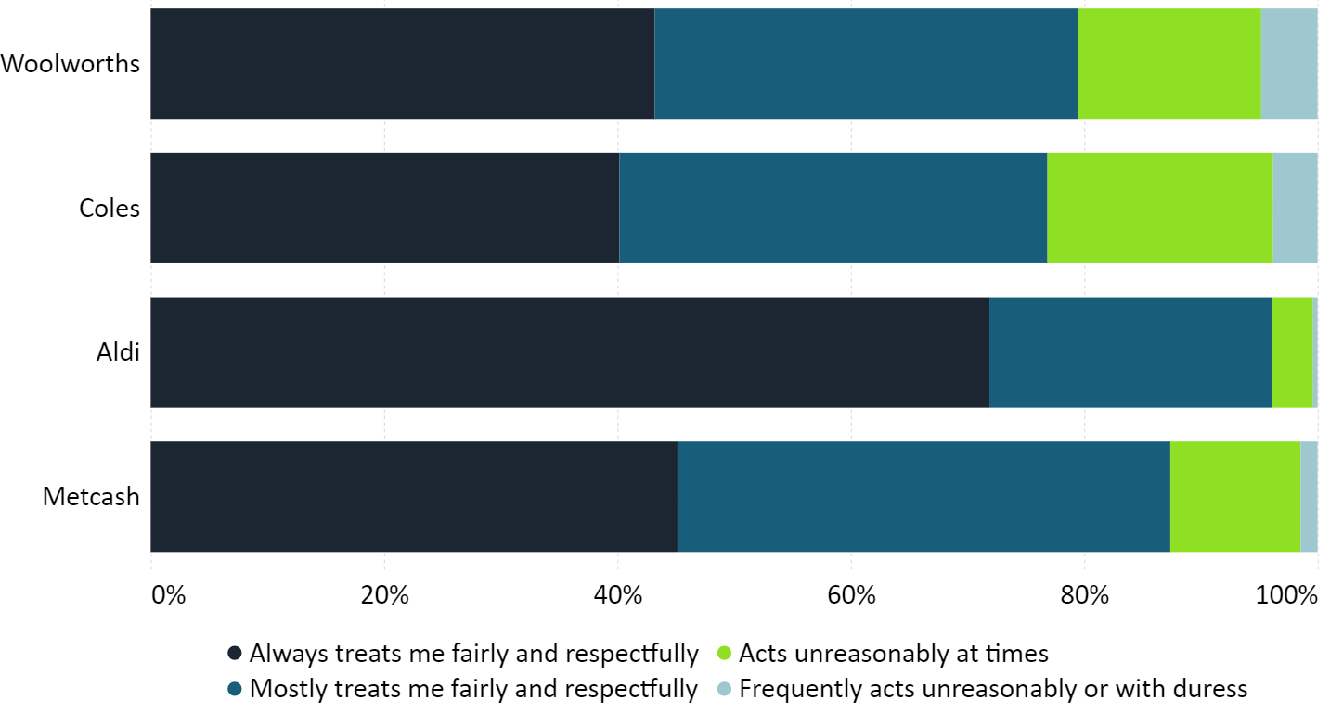

Overall responses to the question indicate that most suppliers have had fair dealings with their respective retailer/wholesaler. Aggregated results for the 4 signatories in Figure 3 are:

* 49 per cent indicated that they were always treated fairly and respectfully by their retailer/wholesaler
* 35 per cent identified that their retailer/wholesaler mostly treated them fairly and respectfully
* 13 per cent identified that their retailer/wholesaler acted unreasonably at times
* 3 per cent identified that their retailer/wholesaler frequently acts unreasonable or with duress

Consistent with results from the past 3 years, Aldi had the highest proportion of suppliers reporting they are always treated fairly and respectfully.

Figure 4 shows how suppliers’ perception of their treatment by retailers and wholesalers has varied over time. While there was a minor increase in the number of suppliers reporting they had been treated fairly in the 2023–24 financial year (49 per cent) compared with the previous financial year (47 per cent), there was also a minor increase in suppliers reporting unreasonable treatment ‘at times’ (12 per cent to 13 per cent) and ‘frequently or with duress’ (2 per cent to 3 per cent).

Figure 4: Industry‑wide results for fair and reasonable dealings across the last 4 years

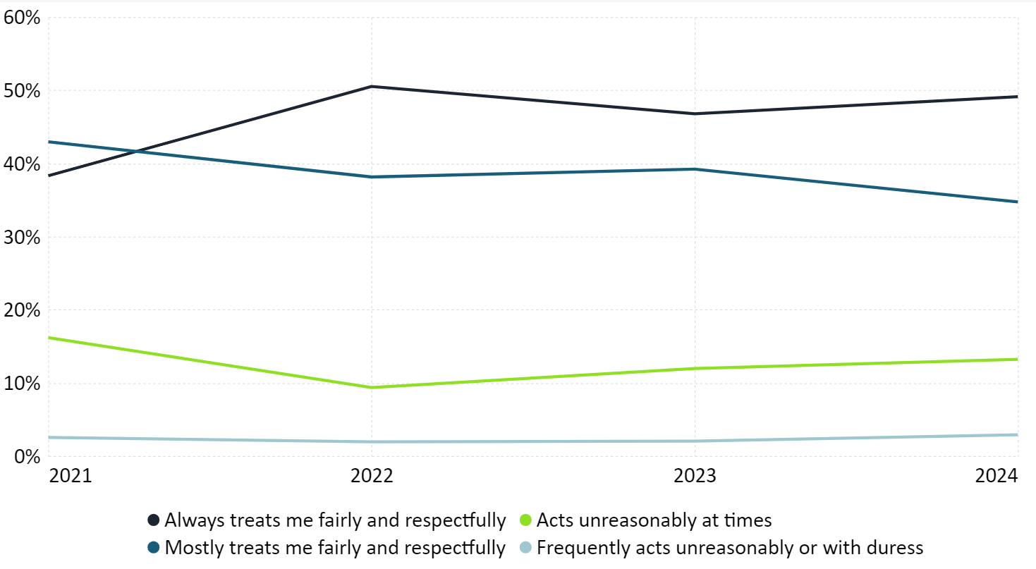

When compared across business size, the results reporting the various treatment experiences was generally consistent. The proportion of respondents reporting they are always treated fairly and respectfully has increased since the beginning of the survey. For all other businesses with a size less than $250 million, the proportion identifying they are always treated fairly and respectfully has decreased or remained the same since last year. This perhaps reflects that larger suppliers may have greater bargaining power than their counterpart suppliers.

Analysing the response results by product shows that fruit and vegetable suppliers have reported a notable improvement in their treatment, unlike in previous years where there has been a decline. There was a 9 per cent increase in suppliers of fruit and vegetables responding that they were ‘always treated fairly’, an 8 per cent decrease in reports of signatories ‘acting unreasonably at times’ and a reduction from 4 per cent to 1 per cent of respondents stating that signatories are frequently unreasonable or act with duress. This may be due to the increased focus and awareness on the particular challenges faced by suppliers of fruit and vegetables. Suppliers of health and beauty products reported the highest results for the categories ‘act unreasonably at times’ and ‘frequently acts unreasonably or with duress’ at 24 per cent and 6 per cent respectively.

### Supplier issues – resolutions

Figure 5: Prompt, constructive action taken by the retailer/wholesaler to resolve issues raised

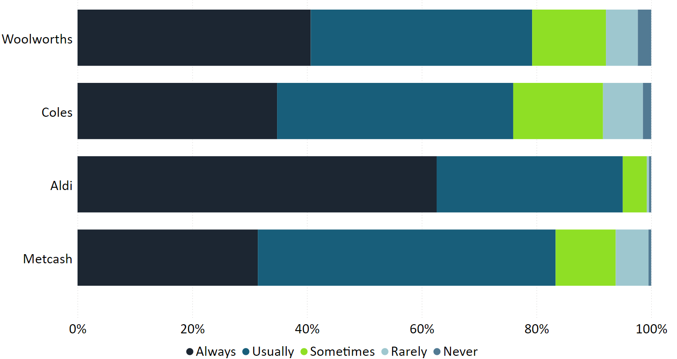

Suppliers reported that Aldi was most likely to take action to resolve issues raised. 95 per cent of Aldi respondents indicated the supermarket always or usually took action to resolve issues – reflecting a 4 percentage point increase on Aldi’s result in the previous year when the supermarket also produced the top result in this category. 76 to 83 per cent of suppliers to Woolworths, Coles and Metcash reported the retailers/wholesaler always or usually took action to resolve issues. These results are largely consistent with last year.

As in previous years, smaller suppliers reported poorer experiences of retailers never taking prompt, constructive action to resolve issues. Unlike previous years, but consistent with other outcomes in this year’s survey, fruit and vegetable suppliers reported some of the best results across product suppliers with 85 per cent of these respondents reporting that the retailer takes action to resolve issues always or usually. Of suppliers reporting signatories always or usually taking prompt action to resolve issues, suppliers of meat and meat products reported the best result with 91 per cent and suppliers of health and beauty products reported the poorest result with 74 per cent.

Across all suppliers, only suppliers of household and cleaning products reported that signatories resolved issues promptly and constructively more than half the time, at 51 per cent. This result demonstrates there remains significant scope to improve the experience of suppliers in the sector.

### Retailer and wholesaler conduct

Suppliers were asked to identify whether they experienced an issue with their retailers/wholesaler during the 2023–24 reporting period. Figure 6 shows that most respondents did not identify an issue, with 64 per cent of suppliers to Woolworths reporting no issues in the reporting period, followed by Coles (68 per cent), and Metcash (74 per cent). Aldi had the highest proportion of suppliers (82 per cent) indicating they had not experienced any issues with the supermarket.

Figure 6: Number of suppliers which experienced no issues with their respective retailer/wholesaler

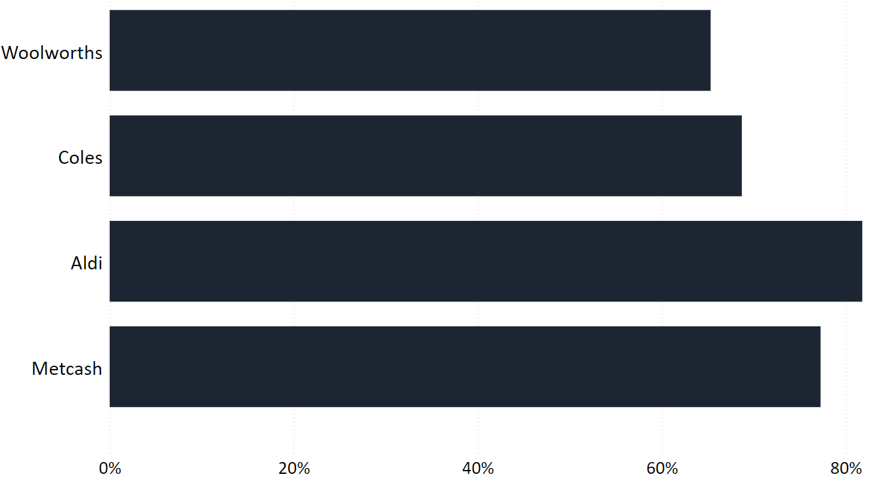

Figure 7: Issues experienced by suppliers with their retailer/wholesaler

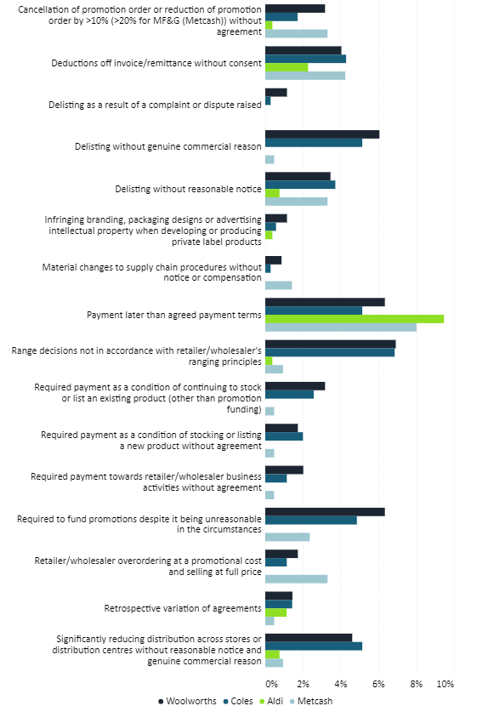

Figure 7 shows the most common issues reported by suppliers across all signatories were ‘payment later than the agreed payment terms’, and ‘deductions off invoice or remittance without consent’. This is consistent with last year’s report. Aldi had the most respondents report late payment times as an issue, followed by Metcash. There has been a marked decrease in the proportion of suppliers to Coles and Woolworths reporting this issue compared to the previous reporting period.

Suppliers to Coles and Woolworths held a higher proportion (approximately 50 per cent) of reported issues across the categories compared with Metcash (29 per cent) and Aldi (18 per cent). Suppliers of Coles and Woolworths reported higher rates of range decisions not being in accordance with the retailer or wholesaler’s ranging principles compared to Metcash and Aldi. These suppliers also reported a significant reduction in distribution across stores or distribution centres without reasonable notice and genuine commercial reason.

All suppliers to Code signatories expressed limited concerns regarding delisting because of a complaint or dispute raised. There were improvements across categories of issues from last year, which include signatories requiring payments outside of existing agreements and while deductions off invoices or remittances without consent continue to be an issue, the proportion of suppliers reporting this issue has reduced across all signatories.

Figure 8: Industry‑wide results for issues experienced across the past 4 years

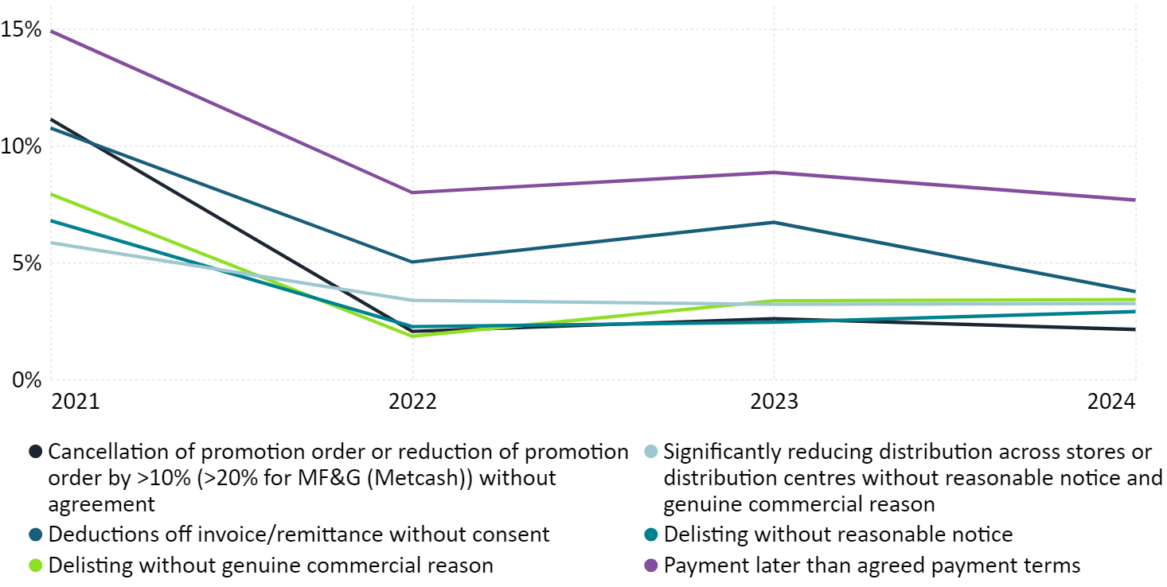

*The issue descriptions were altered following the first survey to better align with the Code’s provisions

** The methodology has been updated because of publishing in Power BI

Figure 8 tracks how supplier experience with the key issues identified in Figure 7 have changed over the last 4 years. These issues being:

1. Payment later than agreed terms
2. Deductions off invoice/remittance without consent
3. Delisting without genuine commercial reason
4. Delisting without reasonable notice
5. Required to fund promotions despite it being unreasonable in the circumstances
6. Significantly reducing distribution across stores or distribution centres without reasonable notice and genuine commercial reason.

This year’s results include the lowest levels of suppliers reporting ‘deductions off invoice/remittance without consent’ since the start of the survey, at 4 per cent, down from 7 per cent the previous year. The other 5 metrics remained the same or varied by only one percentage point.

### Raising an issue with a retailer/wholesaler

Figure 9: Impediments to raising an issue with the buying team

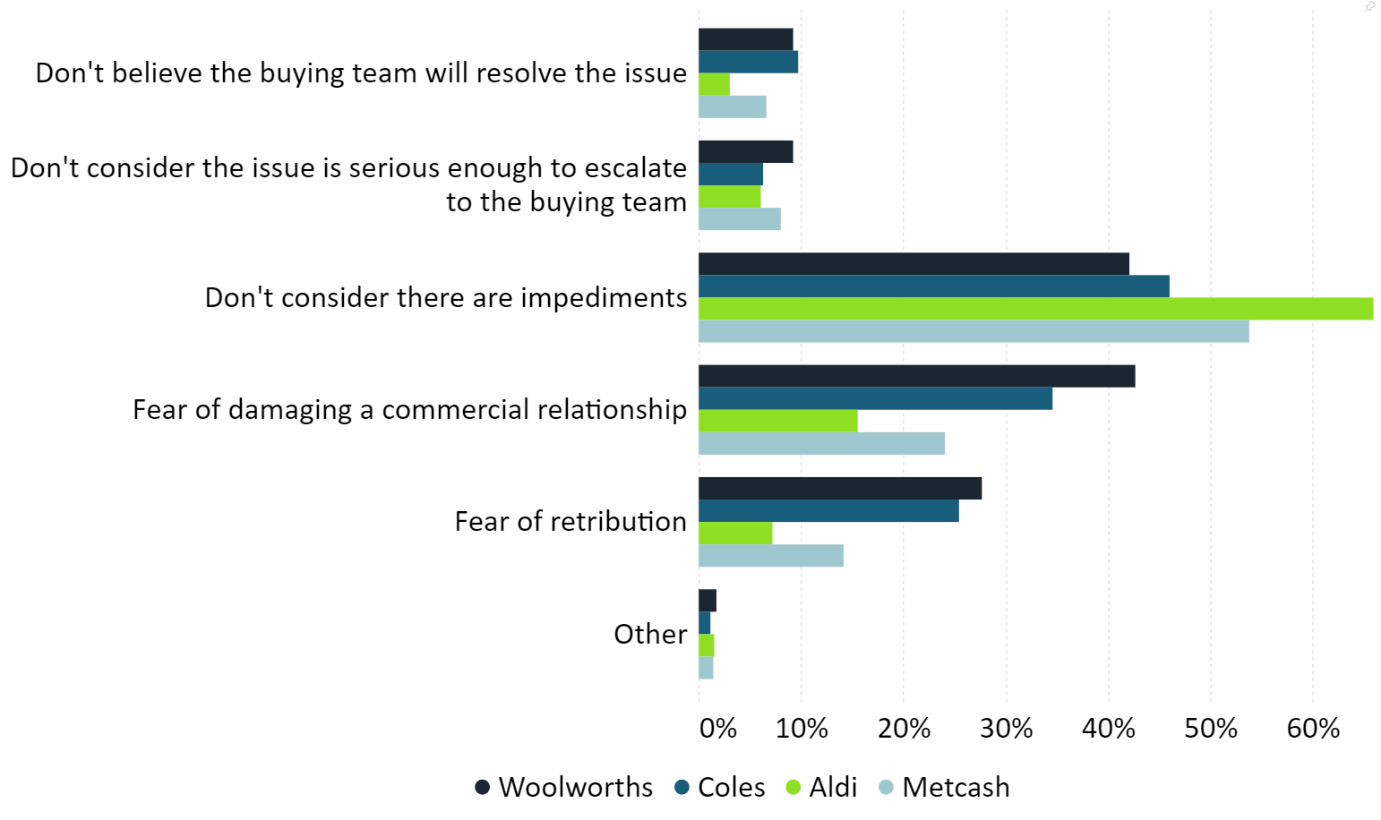

Over 42 per cent of respondents for each of the Code signatories said there were no impediments to raising an issue or concern with their retailer/wholesaler’s buying team. This result is a slight decrease from the previous year (43 per cent).

Of the suppliers that identified impediments to raising an issue with the buying team, fear of damaging a commercial relationship and fear of retribution were the most common reasons. Over 35 per cent of respondents to Woolworths and Coles identified fear of damaging a commercial relationship as a key impediment, compared with 24 per cent for Metcash, and 16 per cent for Aldi.

Overall, 20 per cent of respondents considered fear of retribution to be an impediment to bringing a complaint to their retailer/wholesaler’s buying team, with Woolworths’ suppliers being the most concerned about retribution and Aldi’s suppliers being the least concerned. This is a 3 per cent increase on the previous year’s result and aligns with the results in Figure 11, which for the first time, shows how suppliers retribution concerns have changed since the previous year.

### Bringing a complaint to the Code Arbiter

Figure 10: Impediments to raising an issue with the Code Arbiter

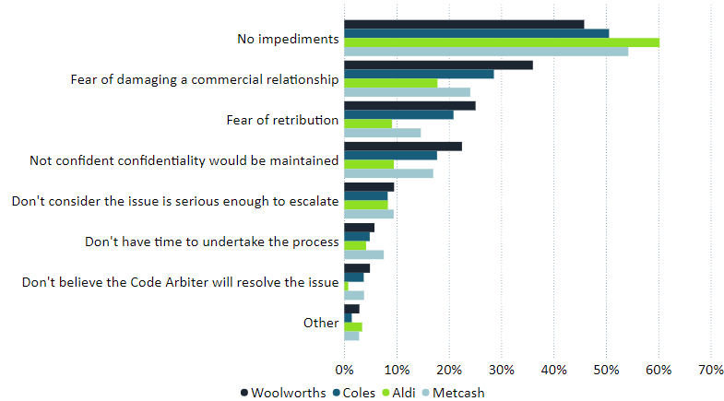

Over 46 per cent of respondents said there were no impediments to raising an issue or concern with their retailer/wholesaler’s Code Arbiter – representing a 9 per cent decrease on the previous year. Of the suppliers that identified impediments, fear of damaging a commercial relationship and fear of retribution were the most common reasons.

36 and 29 per cent of suppliers to Woolworths and Coles respectively identified fear of damaging a commercial relationship as a key impediment, compared with 24 per cent for Metcash, and 18 per cent for Aldi.

Between 9 and 25 per cent of respondents considered fear of retribution to be an impediment to bringing a complaint to their retailer/wholesaler’s Code Arbiter, with Woolworths’ suppliers being the most concerned about retribution and Aldi’s suppliers being the least concerned of the 4 Code signatories.

### Bringing a complaint to the Independent Reviewer

64 per cent of respondents reported that they would consider bringing a decision made by a Code Arbiter to the Independent Reviewer.

Suppliers that answered that they would not consider bringing a complaint to the Independent Reviewer were asked to explain why. Free text answers ranged from concerns of impacting the supplier/signatory relationships, positive faith in the system, fear of retribution, risk of damaging the commercial relationship and it being a time‑consuming process.

### Fear of retribution

This year’s survey included a new question asking suppliers to report how their concerns of retribution have changed since the previous financial year. These results establish an important metric to assess changes in the fear of retribution and assess how the new mandatory code performs in addressing them.

Figure 11: Change in fear of retribution over 2023–24

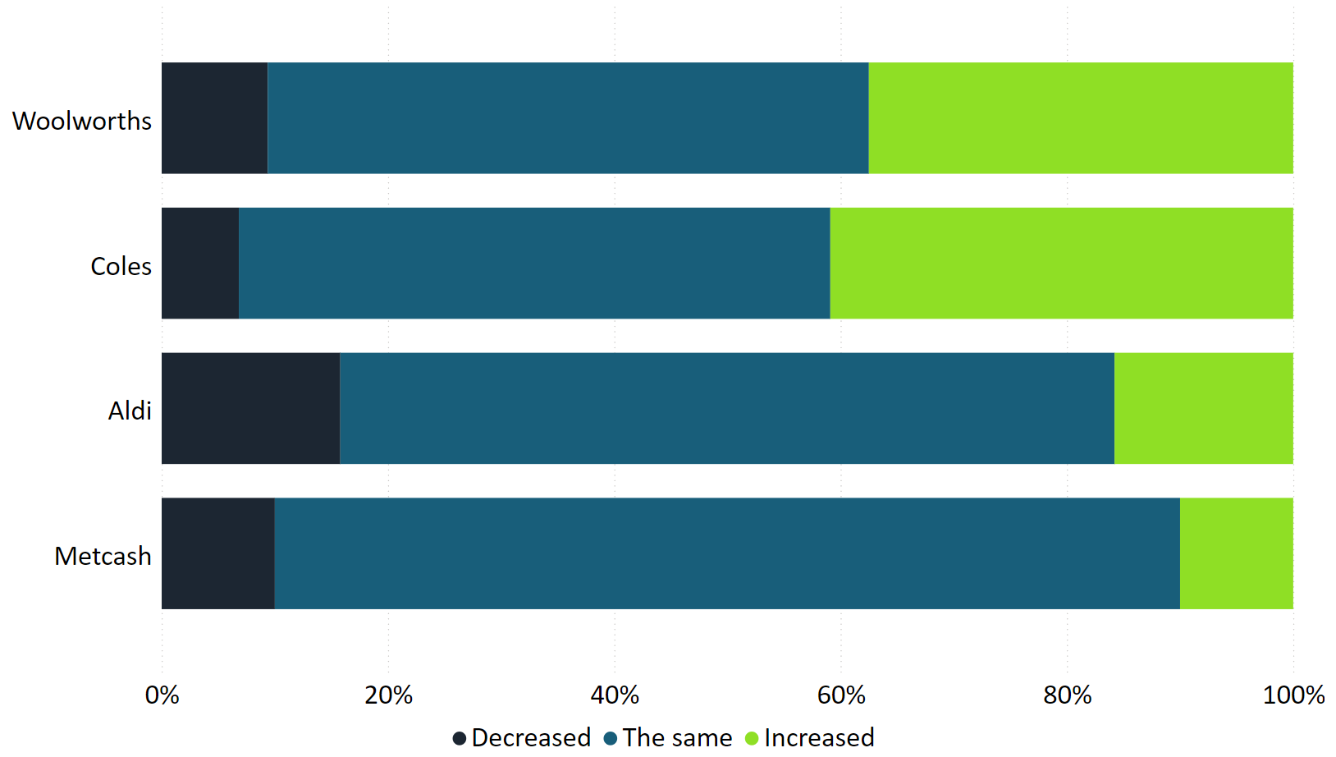

41 per cent of suppliers to Coles reported their concerns of retribution had increased since the previous financial year. 38 per cent of suppliers to Woolworths, 16 per cent of Aldi suppliers and 10 per cent of suppliers to Metcash also reported an increased concern over this period.

The proportion of suppliers reporting that their concerns of retribution remained the same were 52 per cent, 53 per cent, 68 per cent and 80 per cent for Coles, Woolworths, Aldi and Metcash respectively.

Aldi had the highest proportion (16 per cent) of suppliers report a reduction in their concerns of retribution. Metcash had 10 per cent of respondents report a reduction in these concerns, Metcash, 9 per cent and Coles, 7 per cent.

### Contracting out of Code obligations

Supermarkets can contract out of certain obligations under the Code by making exceptions to the Code’s requirements in grocery supply agreements with their suppliers. For the first time, the annual supplier survey has asked suppliers about their experience of having these obligations excluded from their contracts with signatories.

Figure 12: Supplier’s experience of supermarkets contracting out of certain obligations

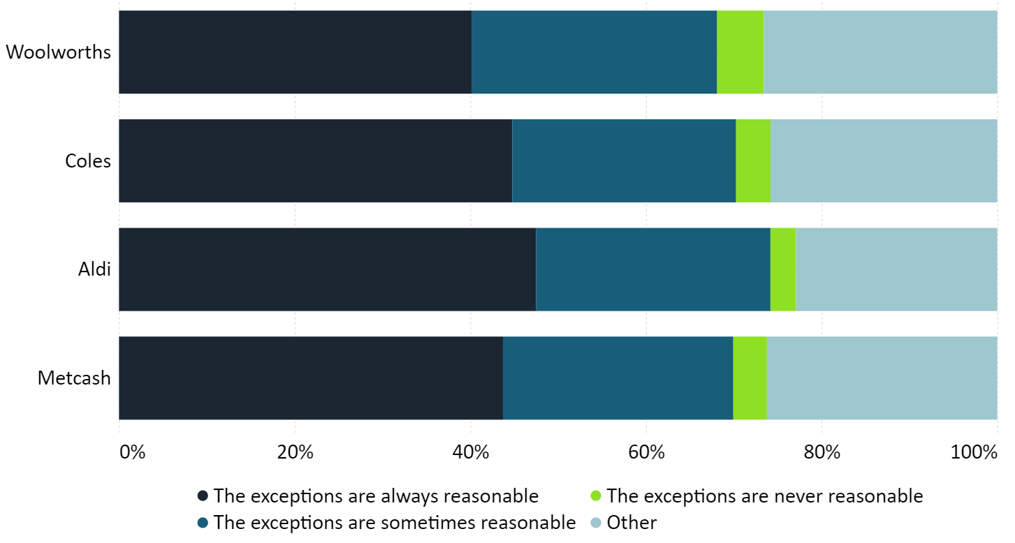

The percentage of respondents identifying these exceptions to be reasonable range from 40 per cent (Woolworths) and 48 per cent (Aldi). Of suppliers reporting that the contract exemptions are never reasonable, results across the 4 supermarkets range from 3 per cent to 5 per cent of all respondents. The notable proportion of suppliers selecting ‘other’ to this question is primarily because of answers by suppliers that have never had an exception to the code contracted out by a signatory. This question will be amended in next year’s survey.

# Overall findings

In the final year of the voluntary Code’s annual survey of suppliers, the results show a notable general improvement in the experience of suppliers since the first survey for the 2020–21 financial year. However, most of this improvement happened in 2021–22. While some metrics have continued to improve in 2023–24 survey, there has been an overall stagnation in survey results, highlighting further areas for improvement.

There are several positive results emerging from the 2023–24 survey. Suppliers of fresh produce, who have previously reported poorer experiences and additional challenges in supplying to signatories due to the perishability of their product, have had some of the best results across multiple metrics including promptness of resolving issues with retailers and reporting to have always been treated fairly. Several issues experienced by suppliers, outlined in Figure 7, show an improvement or limited concerns in a number of categories, including delisting due to a complaint and deductions of remittances without consent. Further, reports of late payment times have significantly decreased on last year’s results for suppliers to Coles and Woolworths.

Adverse results included a 9 per cent reduction in the number of respondents stating there were no impediments to raising an issue or concern with their retailer/wholesaler’s Code Arbiter. This may be explained in part by the high rate (33 per cent) of suppliers reporting their fear of retribution increasing compared to the previous financial year. This issue is further highlighted by the high rates of retribution and damage to commercial relationship concerns reported as impediments to raising an issue with a signatory or Code Arbiter. Feedback from suppliers on the expanded remit of the Code Arbiters enabling them to receive and act on informal complaints continues to be positive.

While responses regarding supplier experience have been generally positive, the share of suppliers identifying they are always or usually treated fairly and respectfully has declined in recent years (to 84 per cent from 86 per cent the previous year and 88 per cent the year prior). Further, smaller suppliers continue to generally be worse off. The survey outcomes demonstrate that small suppliers have had the most challenging experience negotiating price increases and have disproportionately experienced lengthy negotiations taking over 90 days. Additionally, the proportion of small suppliers who have reported raising concerns with signatories in the 2023–24 financial year is 20 to 40 per cent higher than any other business size category.

Across all results in the survey for 2023–24, Aldi has performed the best, followed by Metcash, Coles and then Woolworths. Subsequent annual reports under the new code will continue to track these results and report on how the signatories fare against one another. Readers interested in the metrics of specific categories can investigate the performance of each signatory against its counterparts in the online survey dashboard.

# Observations on the Voluntary Code

|  |
| --- |
| Key observations  The Food and Grocery Code has improved outcomes for suppliers and placed greater focus on the importance of positive relationships between these suppliers and signatories. My assessment overall is that the Code has broad support among the Code signatories and their suppliers.  The introduction of the ‘informal’ dispute resolution process has materially improved outcomes for suppliers and their relationship with Code signatories.  In my observations on the Code in the 2022–23 annual report, I recommended further changes to strengthen the Code. Consistent with my advice, the new Code will continue to permit supplier concerns to be raised with Code Mediators informally, given the overwhelming feedback from stakeholders of its efficacy in resolving disputes.  I am also pleased the new Code includes financial penalties for material non‑compliance with the Code, reflecting the seriousness and impact on suppliers I have observed for such conduct.  The interactive dashboard included since last year’s annual report has increased the transparency and accountability of signatories’ conduct with their suppliers, enhancing competition in the sector by providing a metric that Code signatories can compete on to promote healthy relationships across the grocery sector.  This year, promotional activities were conducted to encourage greater uptake with the annual survey of suppliers. These activities included the Minister issuing a media release, Treasury and the Independent Reviewer posting on social media, and signatories sending reminder emails to suppliers. This resulted in the highest engagement from suppliers than in any of the survey’s previous years. High engagement with the process is important as it provides stakeholders with objective evidence and deepens our understanding of the sector. |

# Activities in 2024–25

* There will be a focus in 2024–25 on supporting the transition to the new Code, which will take effect on 1 April 2025. These activities include:
  + providing support and guidance to suppliers, signatories and other stakeholders on the new Code
  + engaging with Code Arbiters to clarify roles and responsibilities prior to the new Code’s commencement and initiating regular communication once in effect
  + reporting and responding to feedback on the new Code.
* The Independent Reviewer (to be renamed Code Supervisor) will continue regular duties under the Code including:
  + considering requests to review Code Arbiters’ (or Mediators under the new Code) processes in dealing with complaints
  + engaging with stakeholders to identify emerging issues in the sector
  + raising supplier awareness of the Code, Code Arbiters/Mediators and the Independent Reviewer/Code Supervisor
  + supported by the Secretariat, prepare the survey of suppliers and annual report for the 2024–25 financial year, consistent with the requirements of the new Code.

1. Part 1(2) – Purpose of code – Food and Grocery Code of Conduct (2015)
2. IBISWorld, Industry Report ANZSIC G4111: Supermarkets and Grocery Stores in Australia, May 2024, p 24.
3. IBISWorld, Industry Report ANZSIC G4111: Supermarkets and Grocery Stores in Australia, May 2024, p 3.
4. IBISWorld, Industry Report ANZSIC G4111: Supermarkets and Grocery Stores in Australia, May 2024, p 5.
5. IBISWorld, Industry Report ANZSIC G4111: Supermarkets and Grocery Stores in Australia, May 2024, p 24.
6. Australian Food and Grocery Council, Annual Report 2023‑24, (accessed 2 December 2024).
7. Woolworths Code Arbiter Report, [https://grocerycodereviewer.gov.au/code‑arbiter/woolworths](https://grocerycodereviewer.gov.au/code-arbiter/woolworths), pp. 1‑4.
8. Note: there was one complaint reported in Woolworths Code Arbiter’s 2020‑21 annual report; however, there was some doubt as to whether this should be counted given the conduct occurred prior to the Code Arbiter’s appointment and commencement.
9. Coles Code Arbiter Report, [https://grocerycodereviewer.gov.au/code‑arbiter/coles](https://grocerycodereviewer.gov.au/code-arbiter/coles), pp. 1‑4.
10. Metcash Code Arbiter Report, [https://grocerycodereviewer.gov.au/code‑arbiter/metcash](https://grocerycodereviewer.gov.au/code-arbiter/metcash), pp. 1‑3.
11. Aldi Code Arbiter Report, [https://grocerycodereviewer.gov.au/code‑arbiter/aldi](https://grocerycodereviewer.gov.au/code-arbiter/aldi), pp. 1‑2.
12. Note: notifications are per product and multiple notifications may be attributed to a single supplier.
13. See also: Bronwyn Gallacher, [Code Arbiter for ALDI 2023‑24 annual report](https://grocerycodereviewer.gov.au/sites/grocerycodereviewer.gov.au/files/2024-10/ar-2023-24-aldi.pdf), page 2.
14. Total is approximate.
15. Includes suppliers providing goods not defined as ‘groceries’.
16. Pet food suppliers are aggregated into the count of “other” in the survey dashboard.